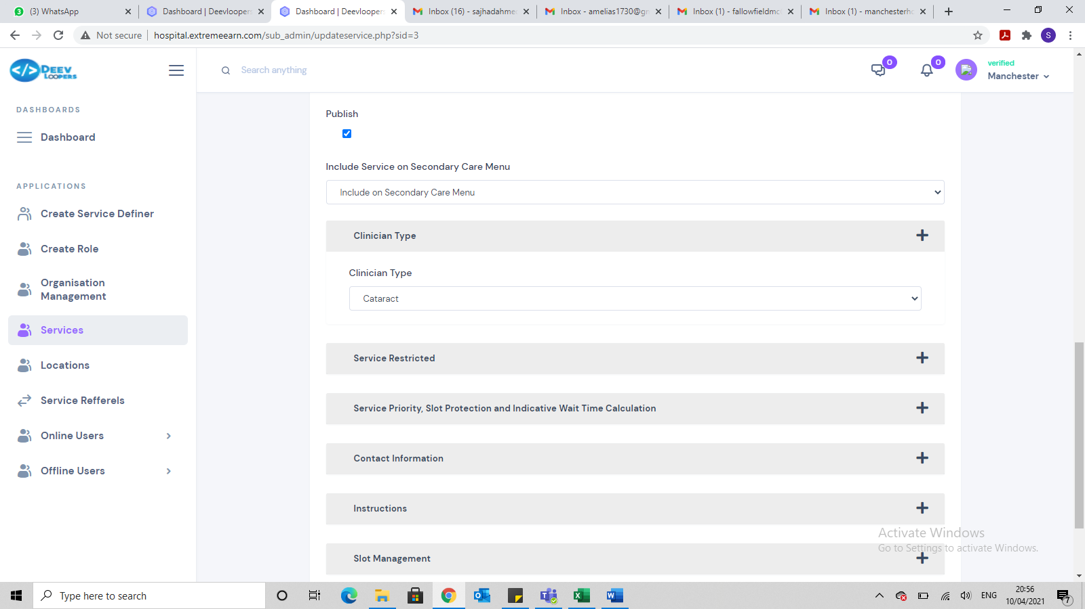

Allow for multiple clinic types to be selected, when creating a service.

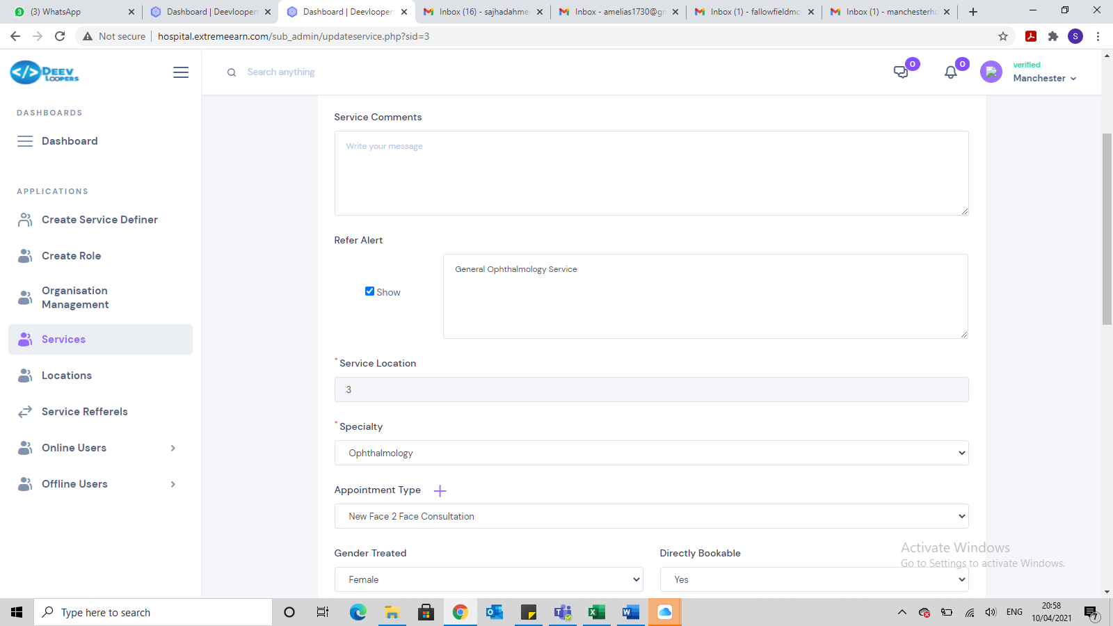

Instead of showing the actual location I selected it is showing the number 3?

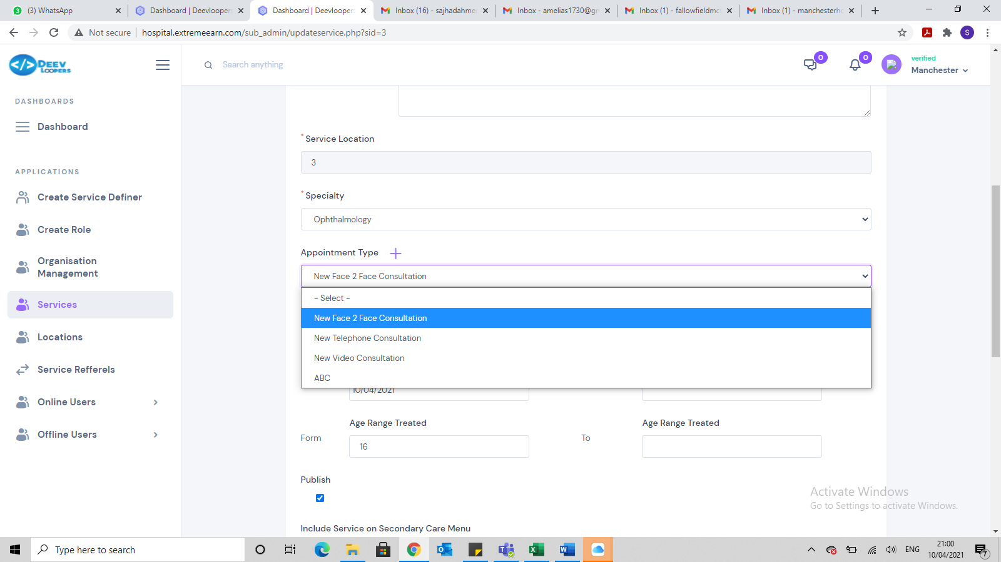

Allow for multiple appointment types to be selected, when creating a service.

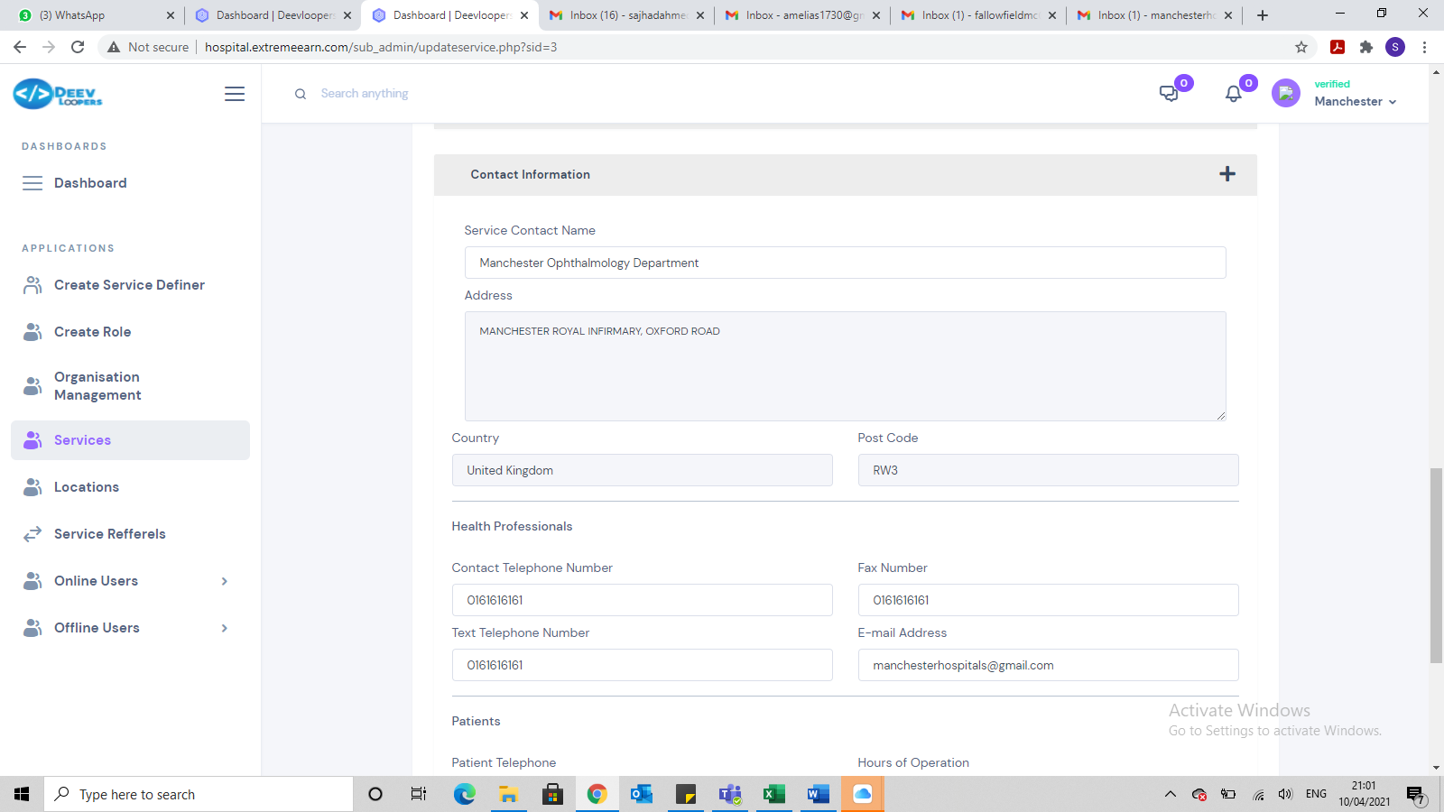

Its picking up the incorrect field. This should be the Post Code not the organisation code. This is only apparent when the service is saved and then you go back into it.

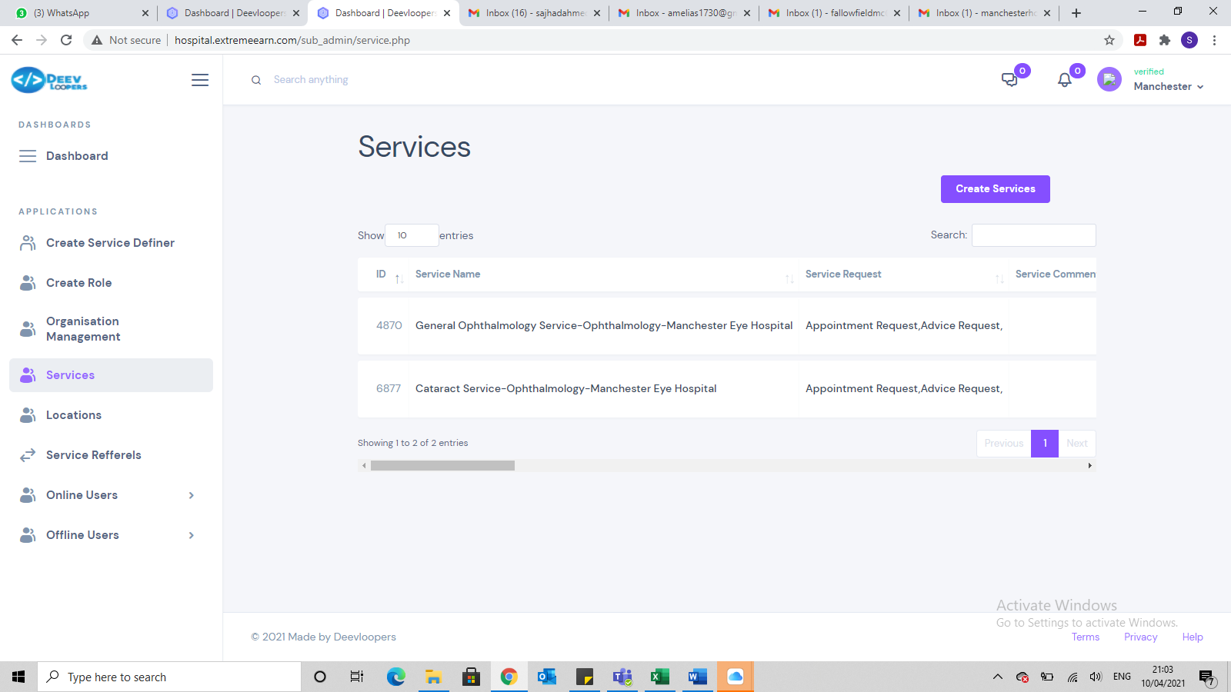

Why are the ID numbers not sequential? I created these 2 services within 5 mins of each other.

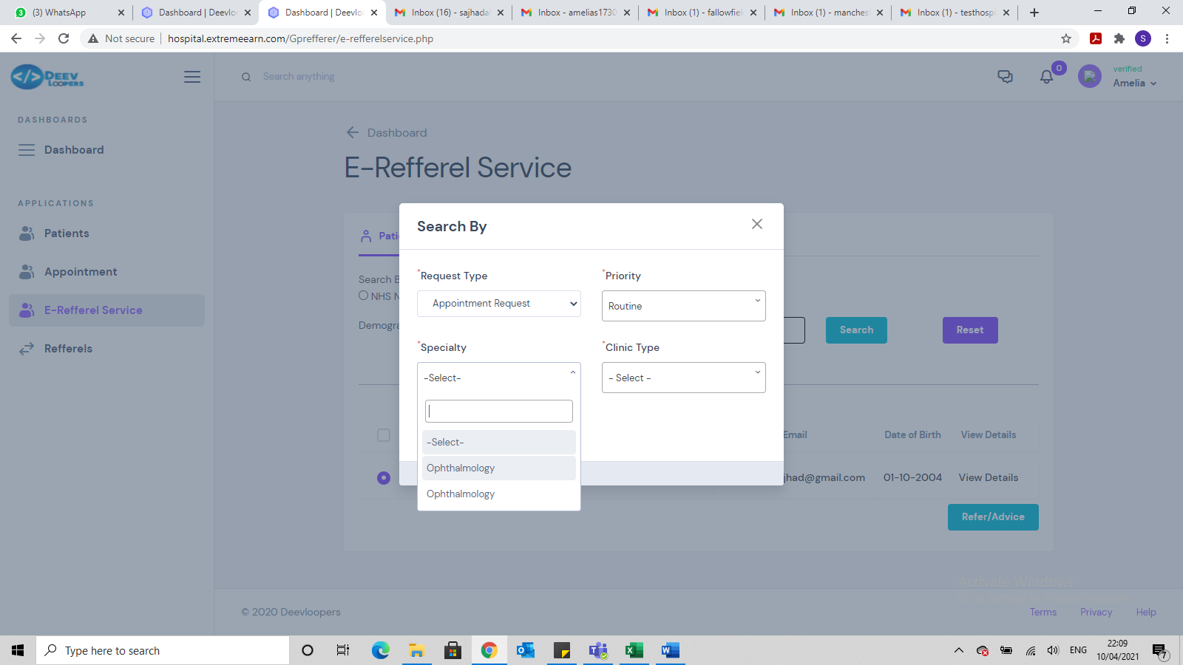

I created 2 Ophthalmology services for Manchester eye hospital and rather than having Ophthalmology listed once, it has listed the speciality twice. It should only be once.

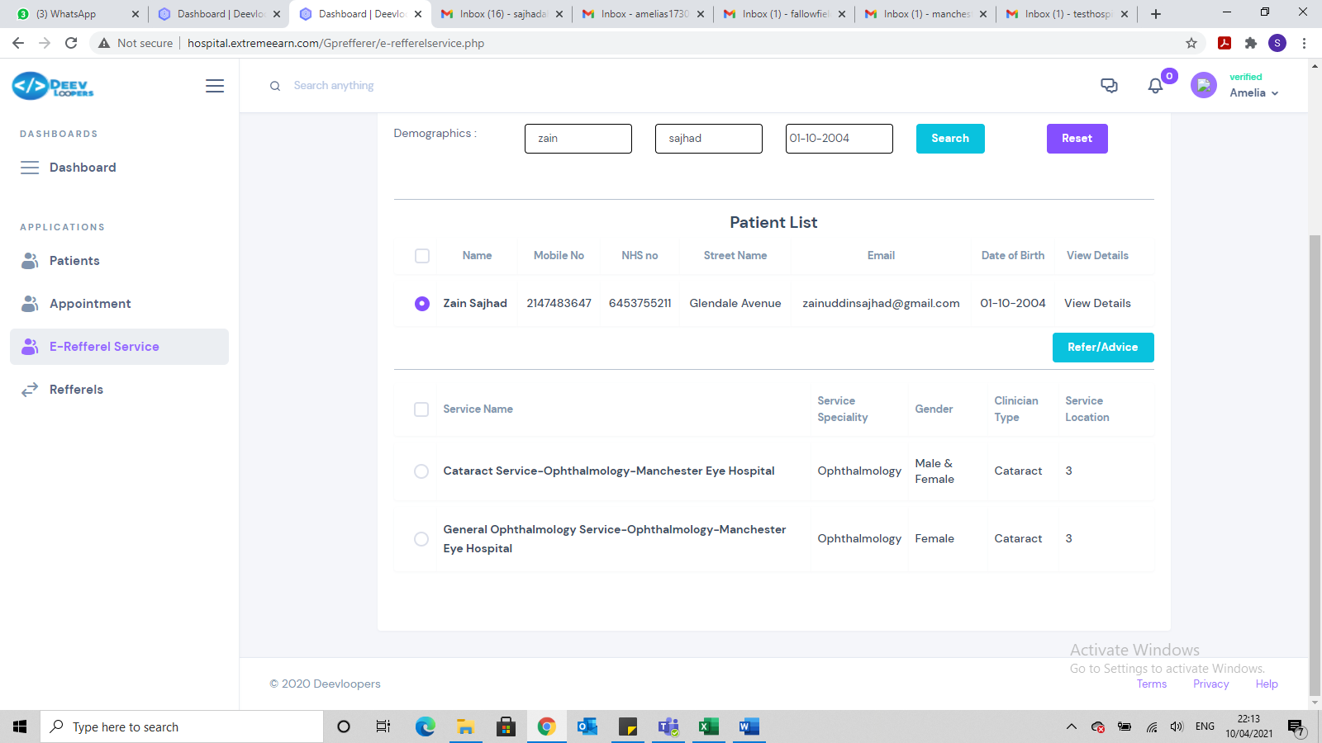

This is a male patient but it has listed a service which is for females only, in addition to the male & female one. The services listed should doing a logical query, so a male patient cannot be referred to a female service and a female patient cannot be referred to a male service. It should also be age sensitive. So if the patient is too young or too old, then the service should not be available for the patient to be referred too.

* Mobile contact number for the patient I created is completely wrong.
* Need to link named clinician to the Services.
* Once patient is created by a GP, the page retains some of the original patient details, rather than resetting the page.
* When at e-referral page, need to have the ability to update patient details, rather than having to go via patient search facility.

New testing results from Monday 12 April 2021

* When registering organisations, it allows you to register 2 organisations with the same organisation code. This code must be unique.

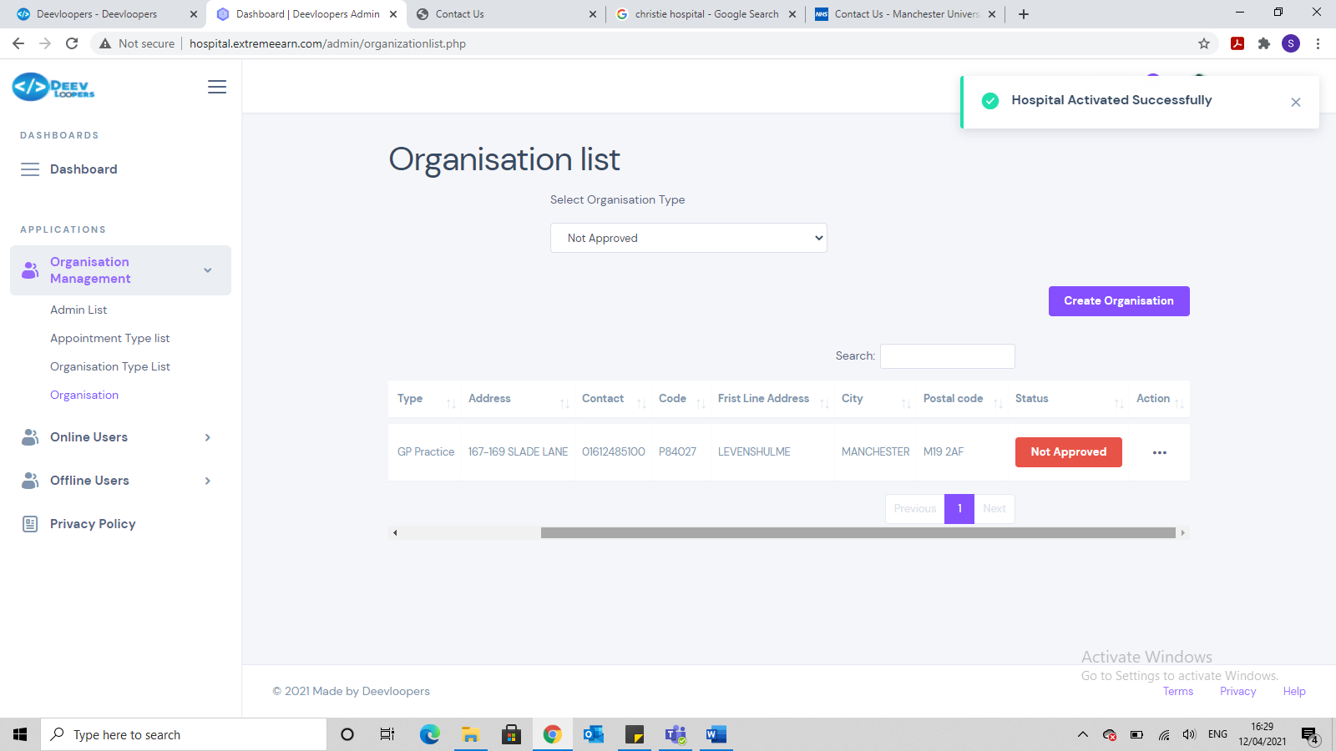

When approving an organisation it always states Hospital Activated Successfully, even when it is a GP practice. Can this be reworded to state the name of the organisation for e.g. Fallowfield Medical Centre activated successfully.

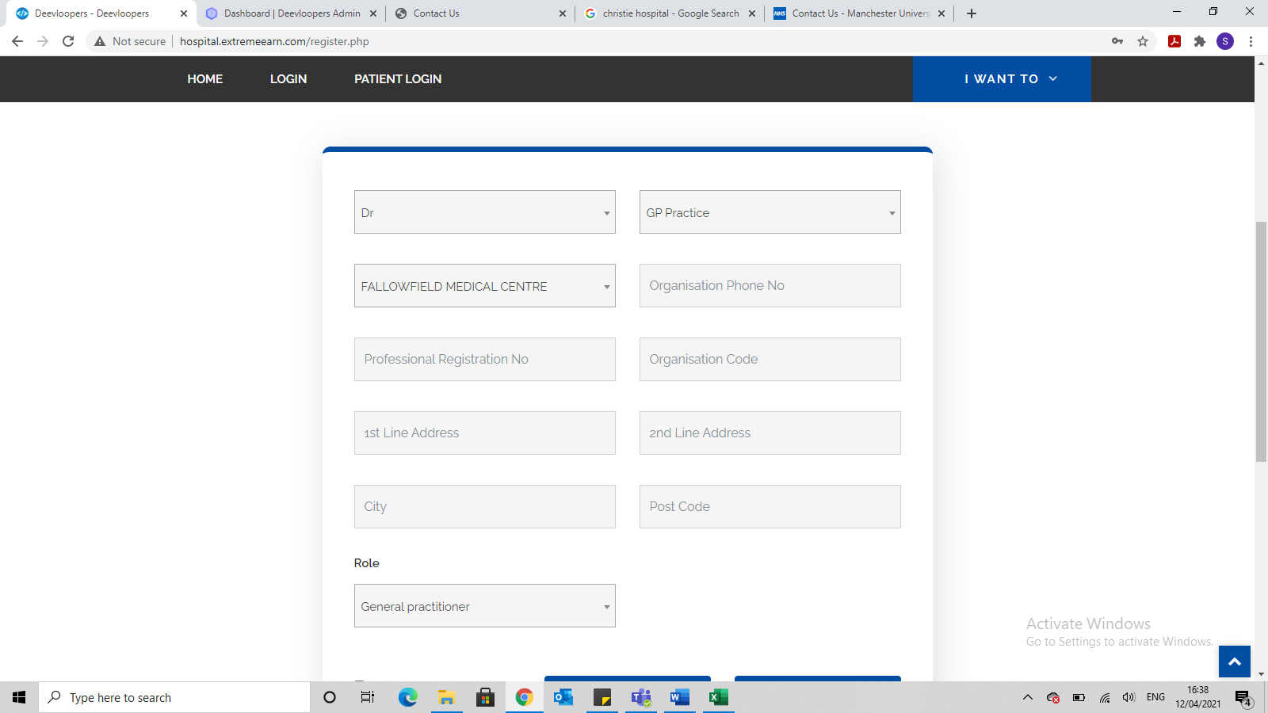

Once a GP or Consultant has registered themselves from the website front end, the page doesn’t reset and clear the fields.

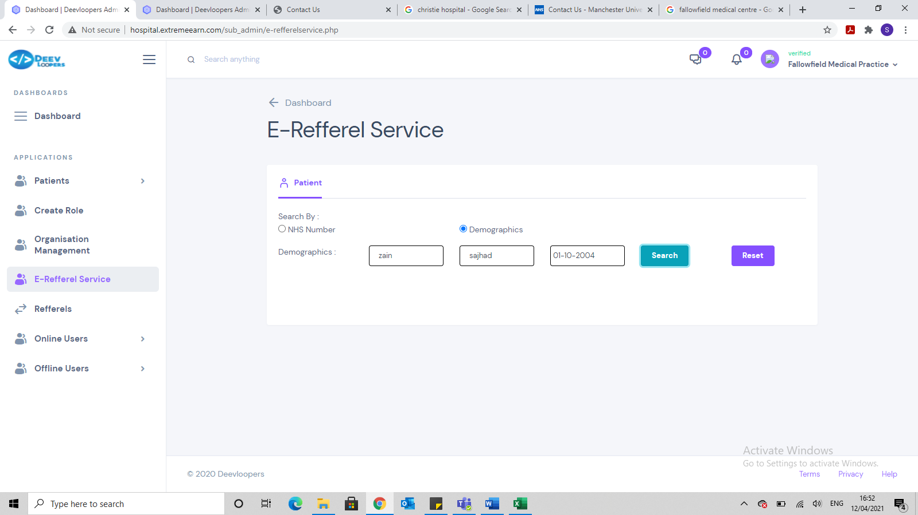

There should be functionality to create the patient from this E-referral service page also.

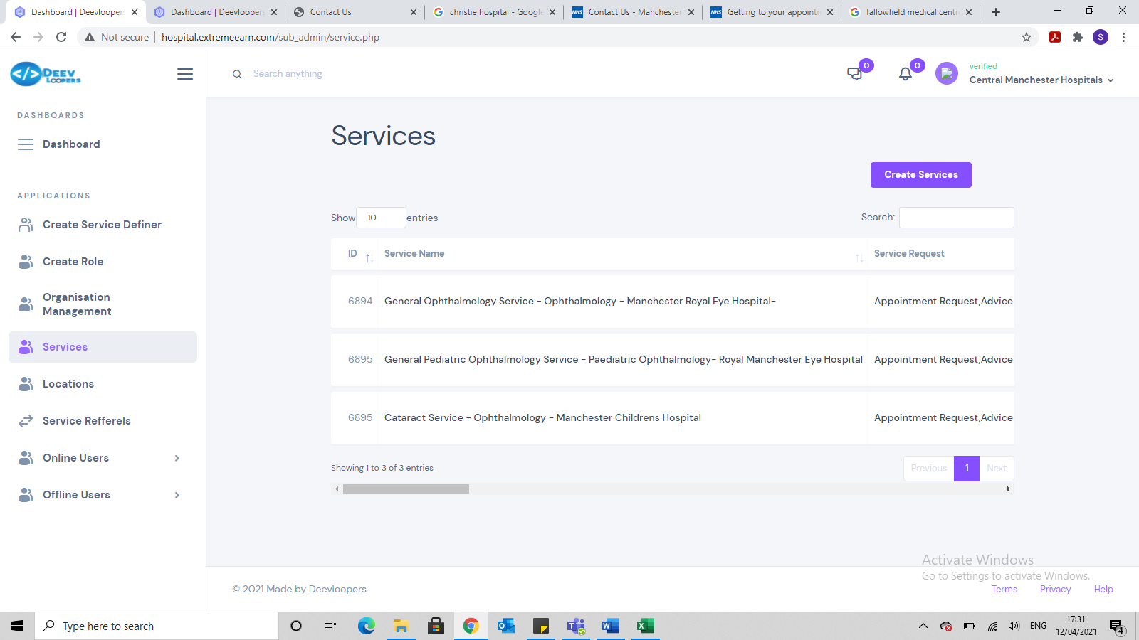

I created 3 new services. The first one had a unique ID but the second 2 had the same ID?

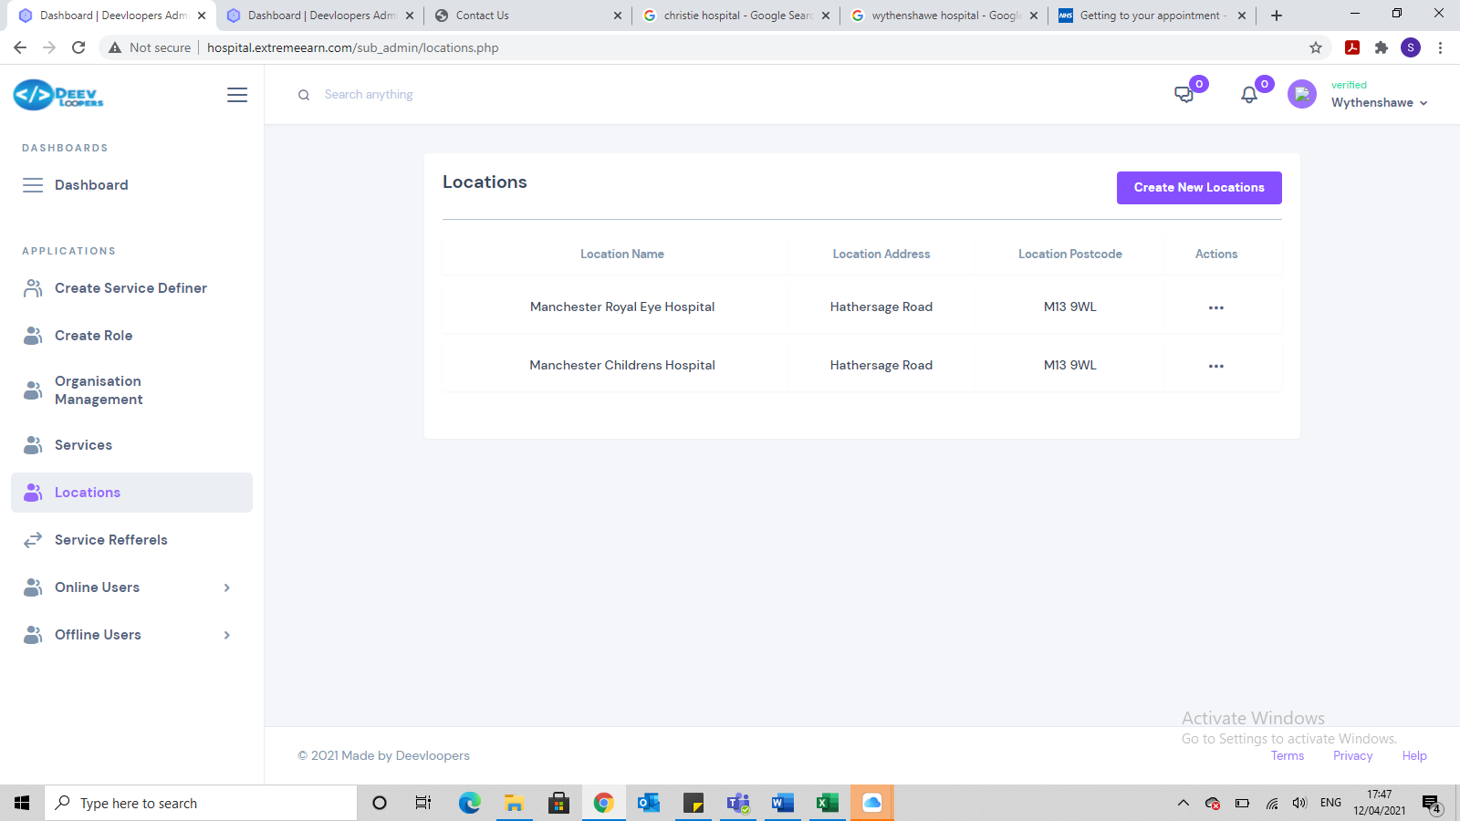

I set these 2 locations up for CENTRAL MANCHESTER UNIVERSITY HOSPITALS NHS FOUNDATION TRUST …not for UNIVERSITY HOSPITAL OF SOUTH MANCHESTER NHS FOUNDATION TRUST but they have appeared in this one too.

Also the services I created for CENTRAL MANCHESTER UNIVERSITY HOSPITALS NHS FOUNDATION TRUST are also appearing in SOUTH MANCHESTER NHS FOUNDATION TRUST

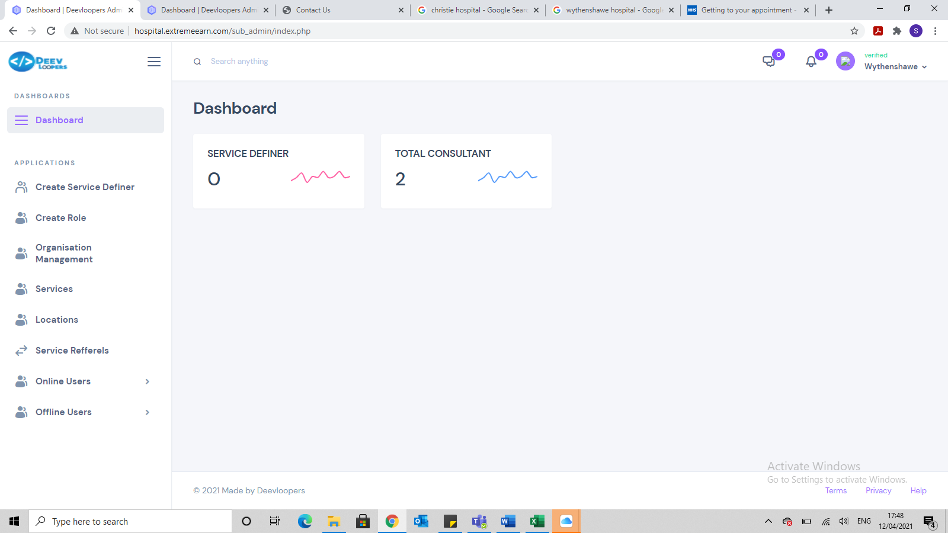

Dashboard is saying there are 2 consultants setup but I haven’t setup any consultant for this new hospital. I setup 2 new consultants for another CENTRAL MANCHESTER UNIVERSITY HOSPITALS NHS FOUNDATION TRUST …not for UNIVERSITY HOSPITAL OF SOUTH MANCHESTER NHS FOUNDATION TRUST

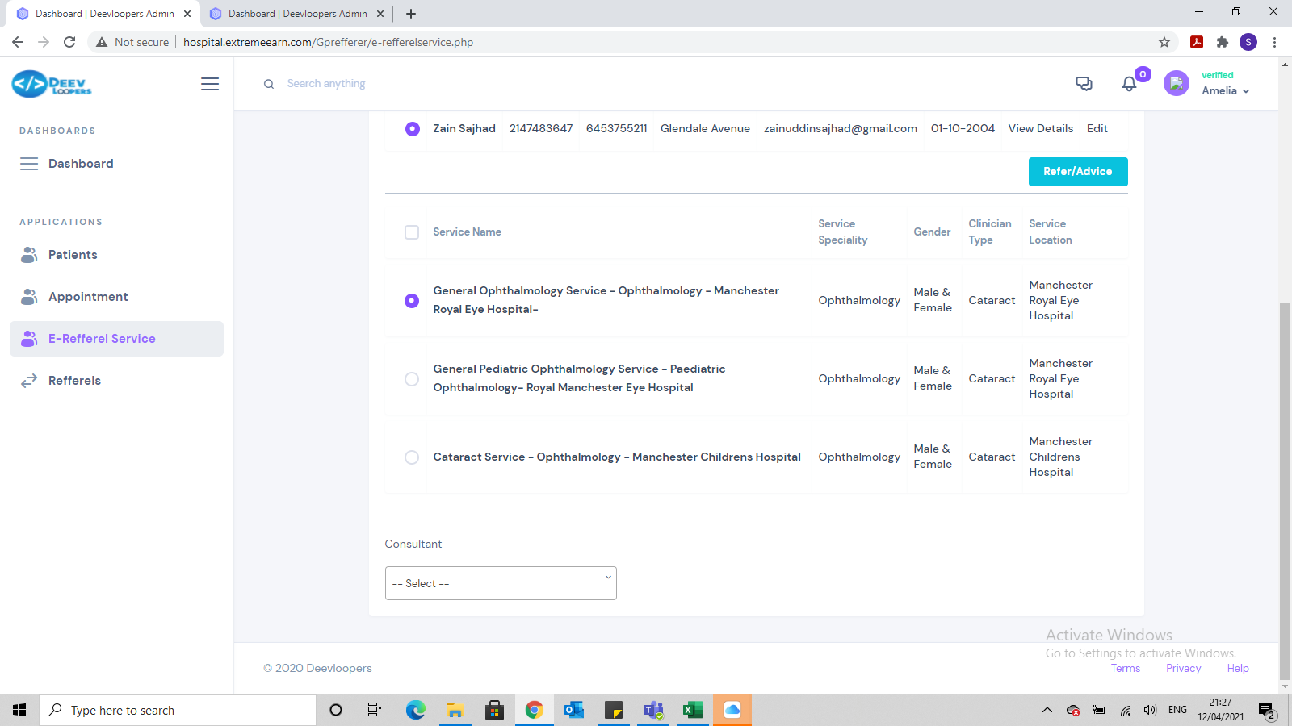

I am unable select the 3 service. I can only select the first two

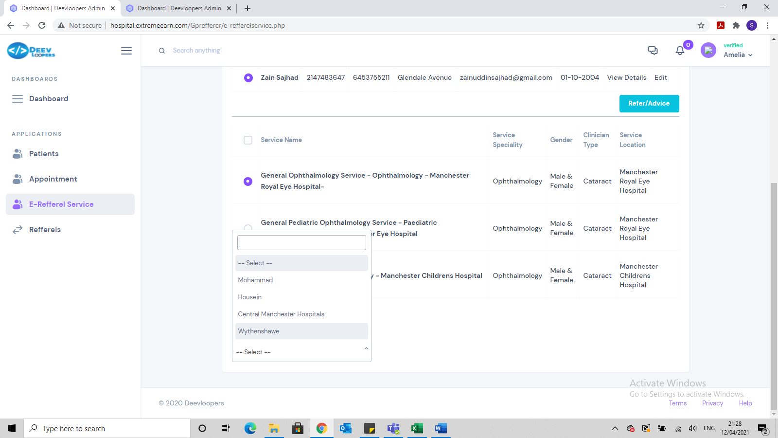

It is now letting me select consultant but it also is including the hospital locations in the Consultant option, which is incorrect.

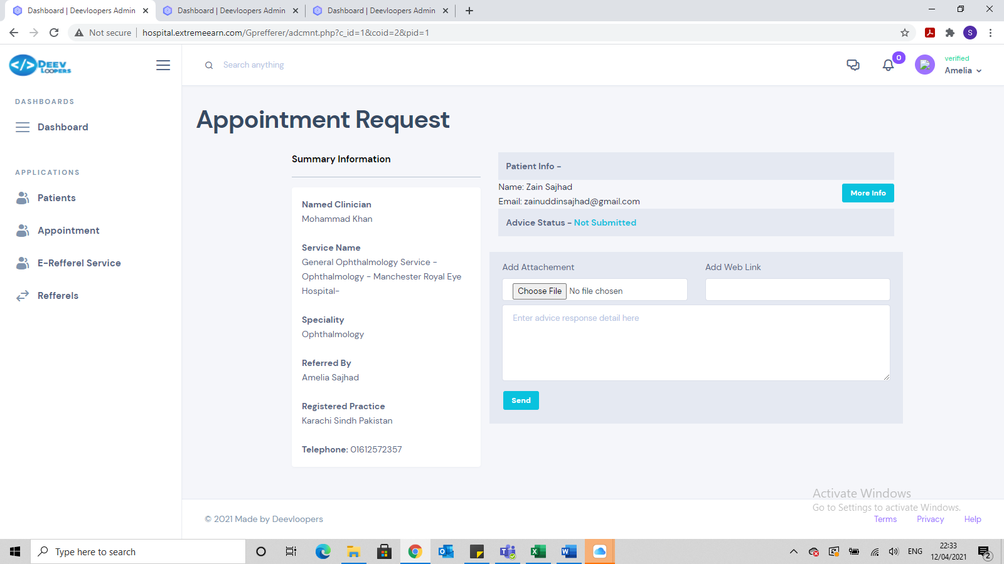

This screen is still showing the incorrect GP Practice. It is showing Karachi Sindh Pakistan but it should be Fallowfield Medical Centre

Also need to show the patient details clearly without having to click on more info. Information should be:

First name, Surname, D.O.B, Home address and mobile contact number

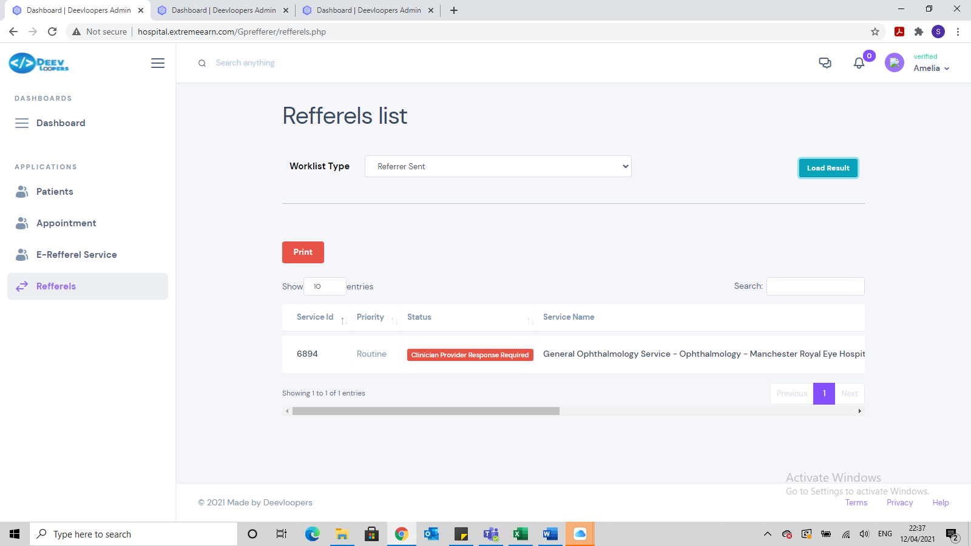

Here it should be referral ID not Service ID. This page is for all the referral the GP has referred and so the GP does not need to see the service ID but rather, they need to see the referral ID. Every single referral should have the following:

* Unique referral ID
* Date of referral created
* Name of person who created the referral
* Date referral was sent
* Name of person who sent the referral
* Date referral was accepted/rejected
* Name of person who accepted/rejected the referral

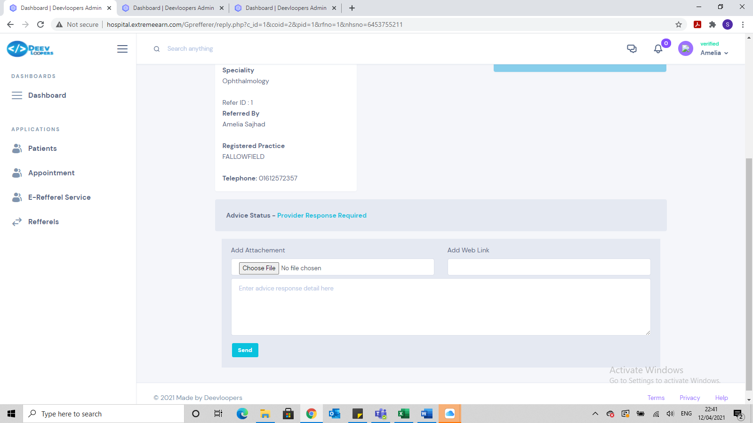

We need to develop this page further. It is not very user friendly and too much scrolling.

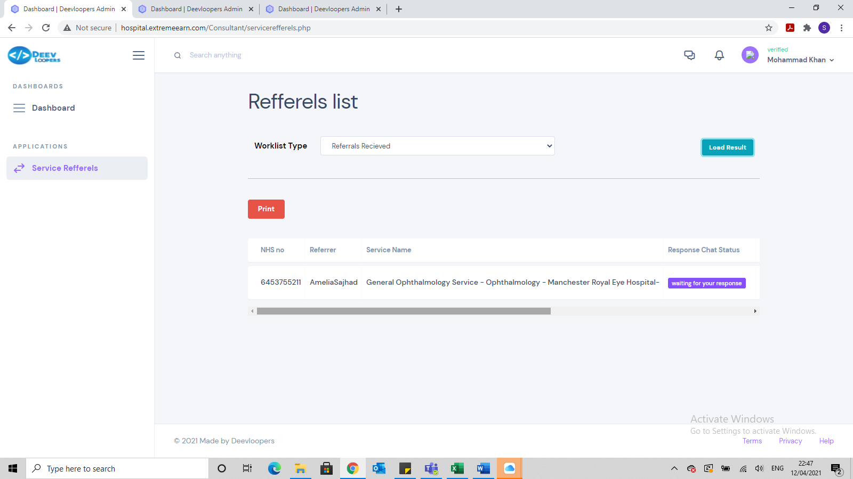

We need to develop this page further. It is not very user friendly and too much scrolling.

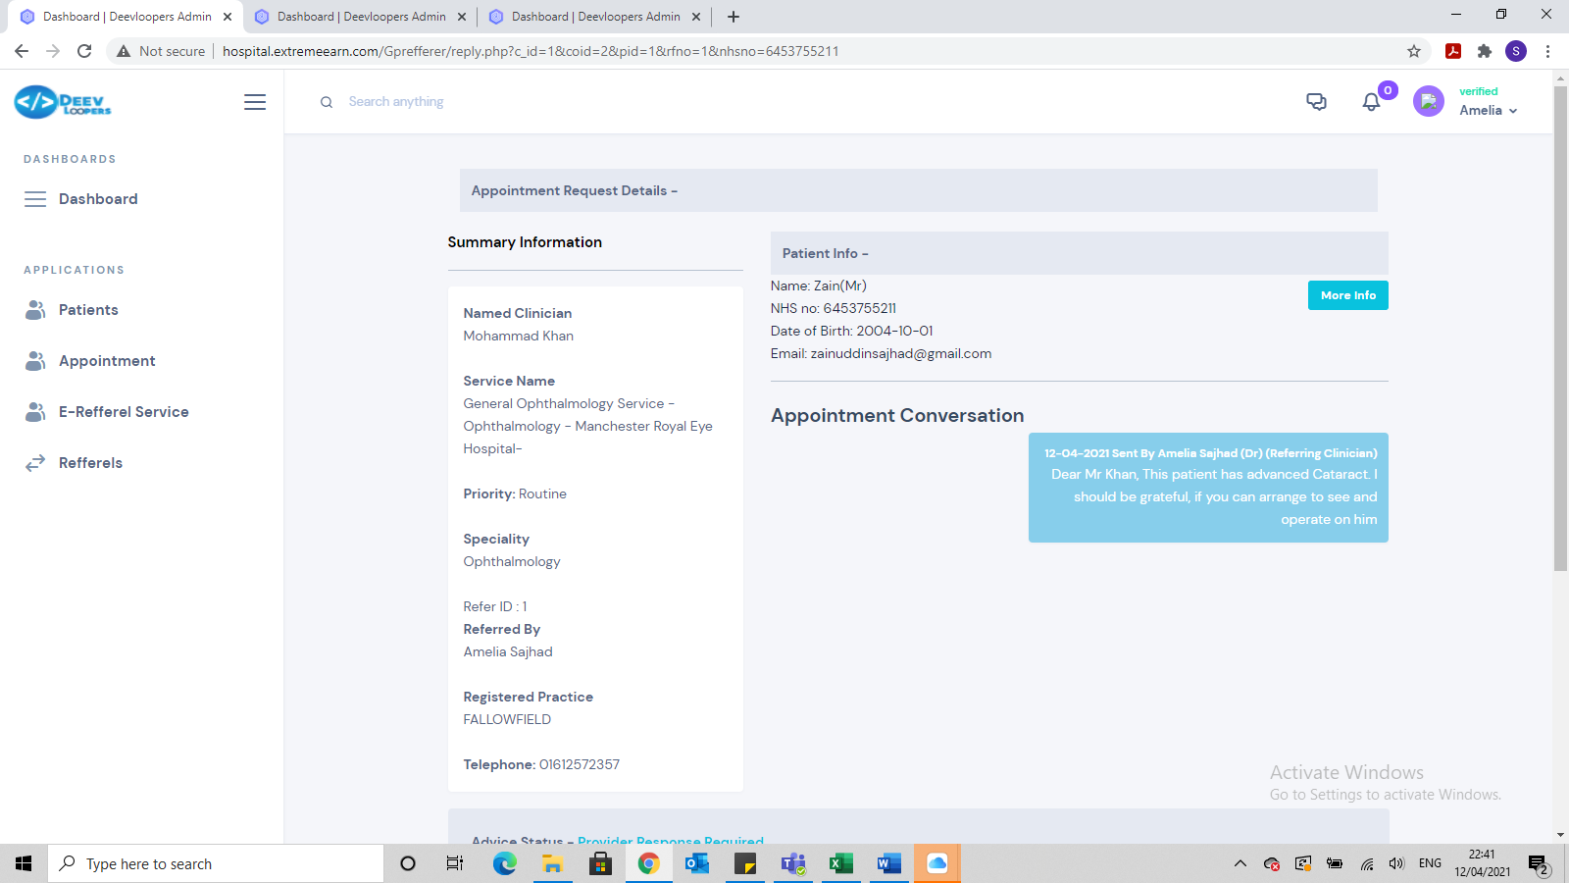

We need to develop this page further. It is not very user friendly and too much scrolling.

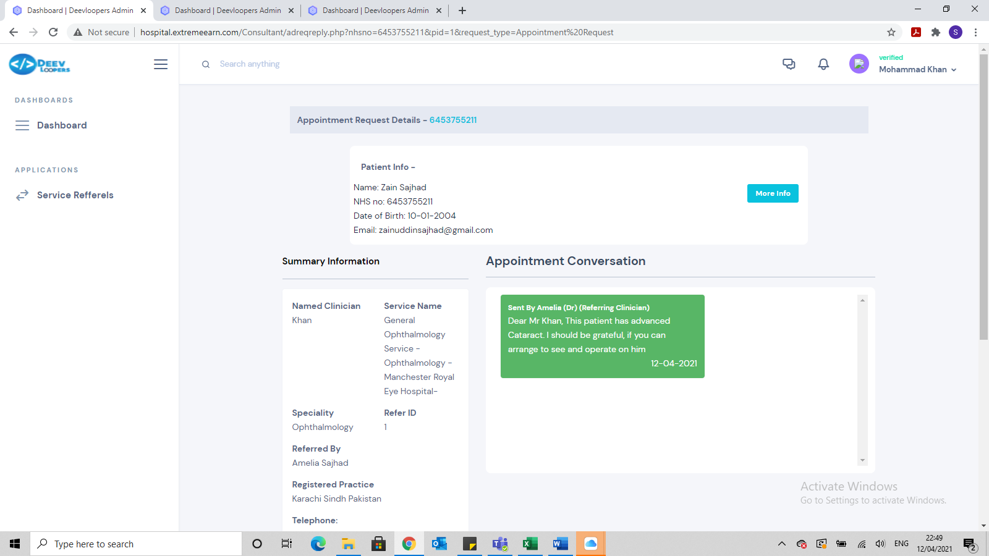

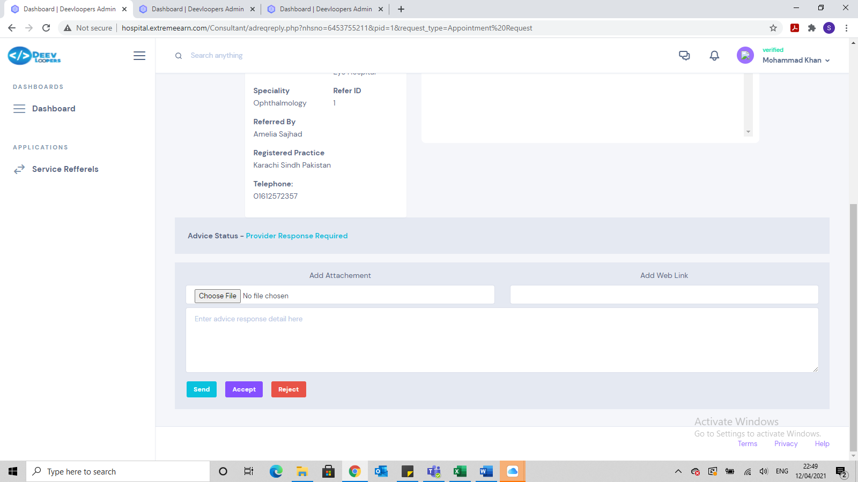

We need to develop this page further. It is not very user friendly and too much scrolling.

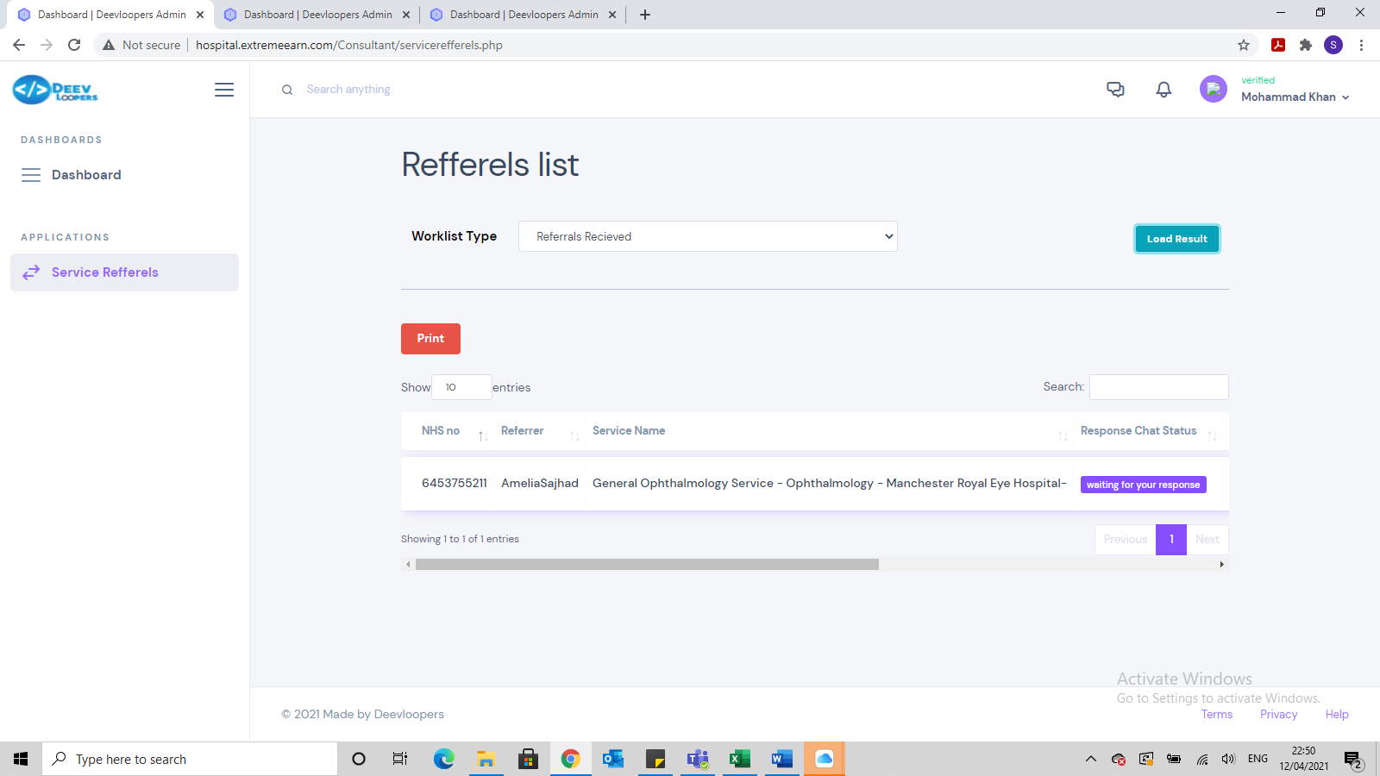

Referral has been accepted but still is sitting in Referral received worklist and also in referral accepted worklist. It cant be in both, only 1

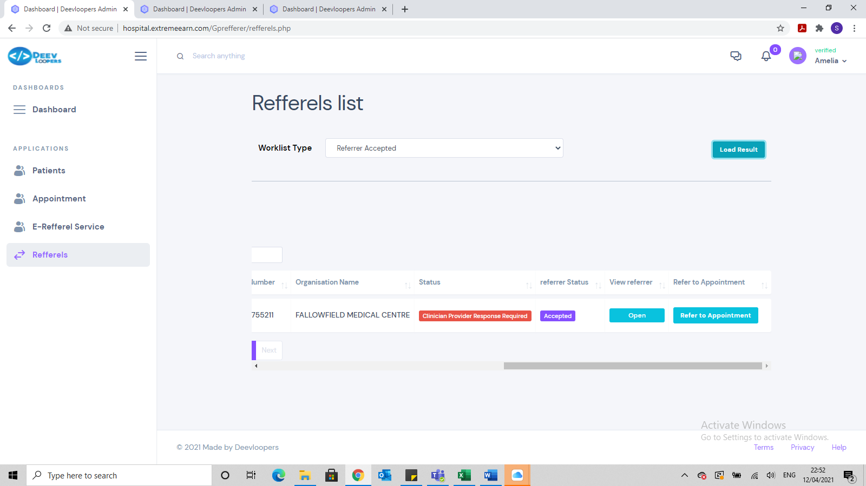

When logging into GP, it has moved the referral from sent to accepted worklist, but it still states in red Clinician Provider Response Required, which is incorrect

Testing on 15 April 2021

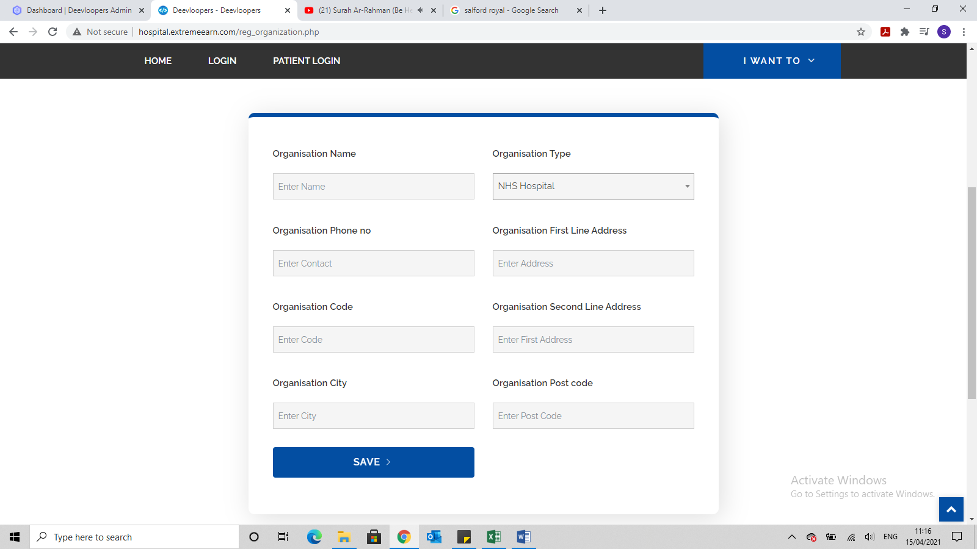

Once a new organisation I registered, this page should disappear and go back to the home page

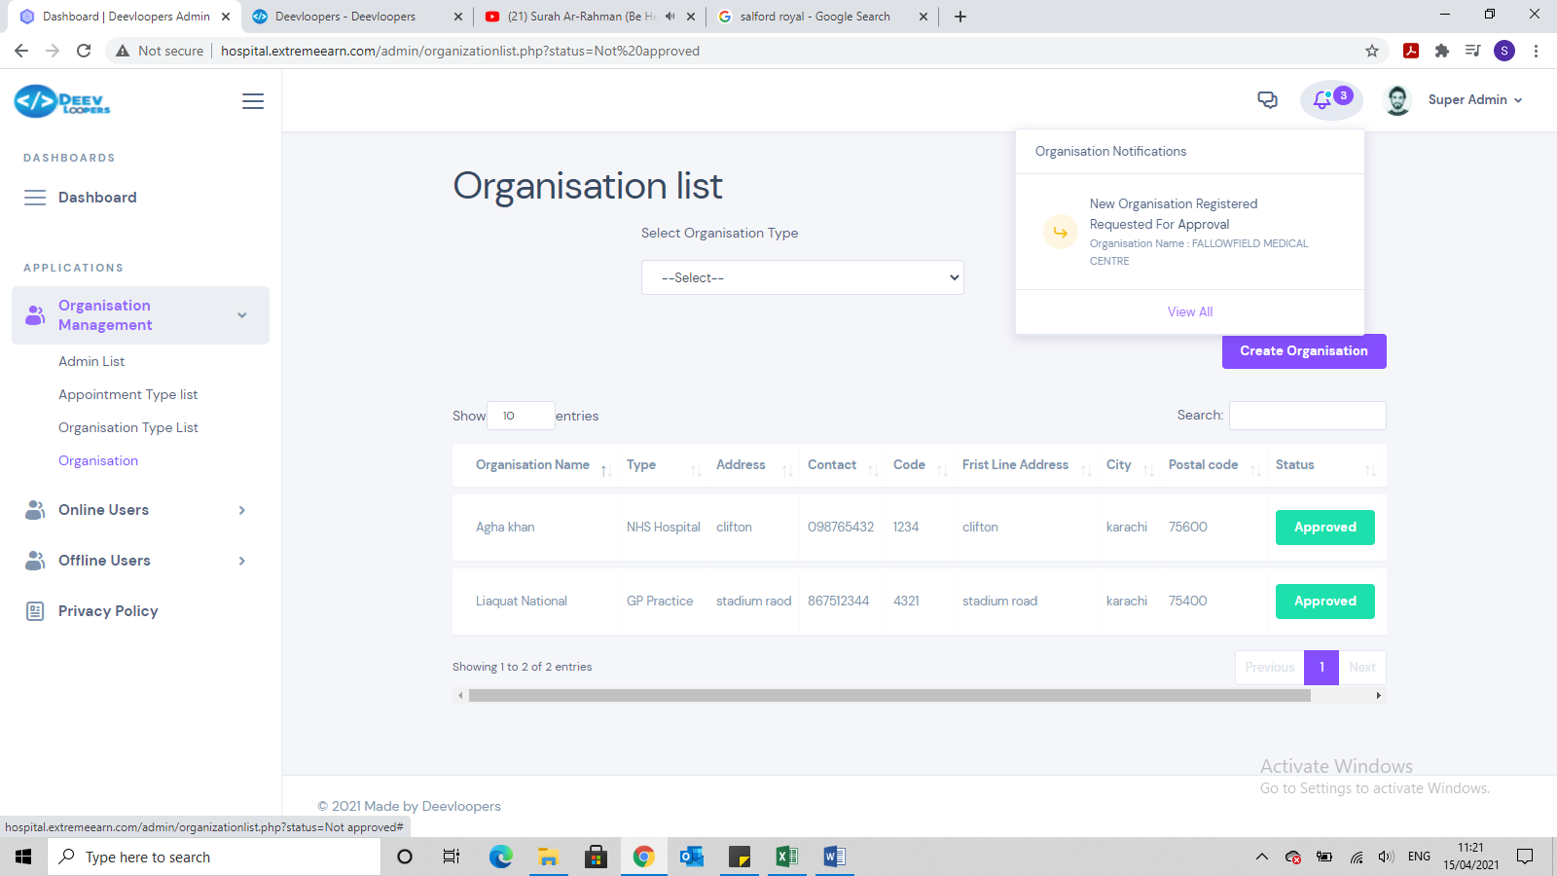

When clicking on the bell icon to see the message, it should go to the correct page. The correct page would be the Not APPROVED page

Also once you have approved an organisation, the page automatically goes to the approved organisations page but it should stay on the Not Approved page.

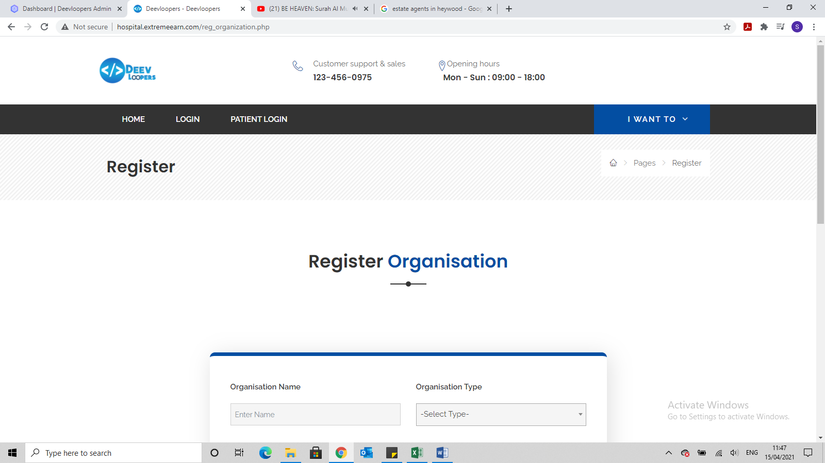

This page needs to move up. Too much scrolling

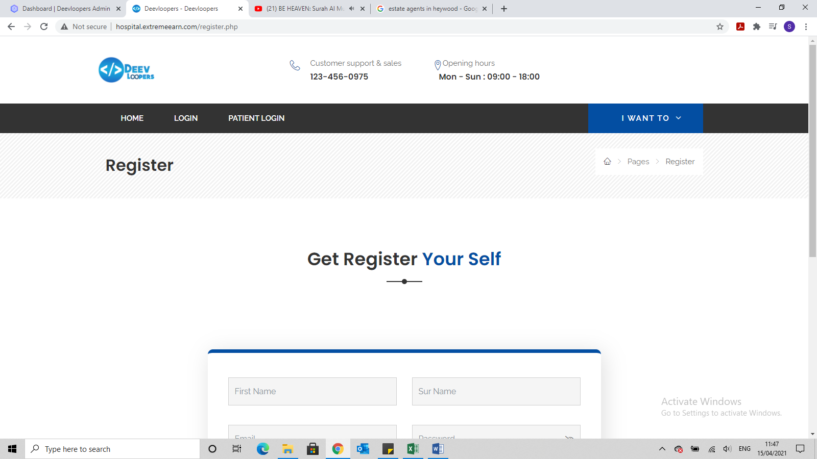

This page needs to move up. Too much scrolling

Also Sur Name box needs to read Last Name

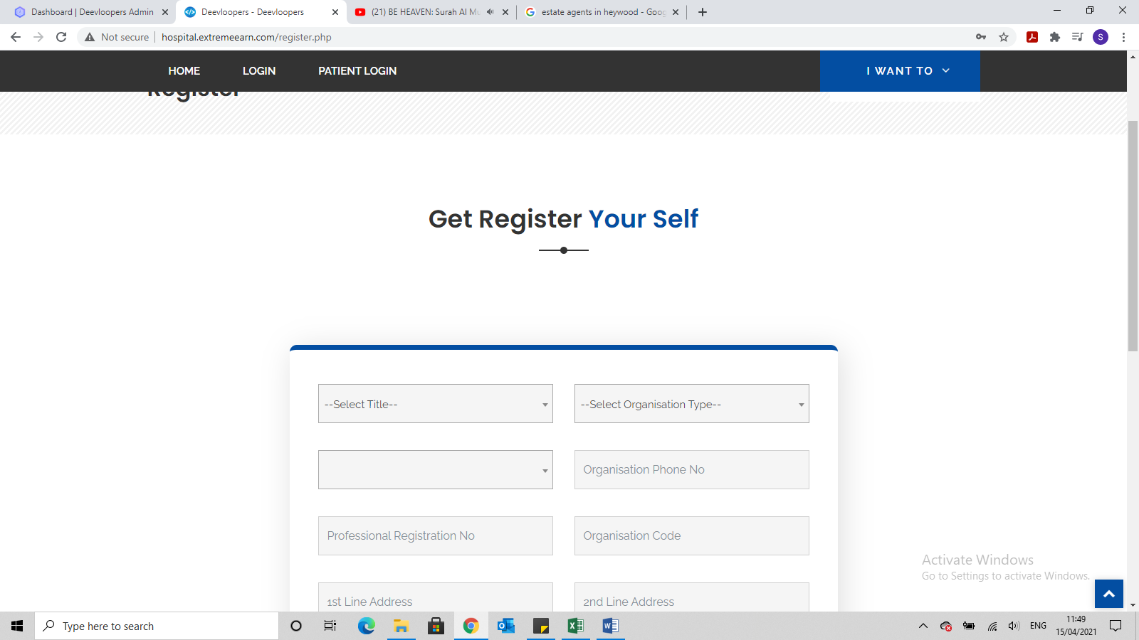

This page needs to move up. Too much scrolling

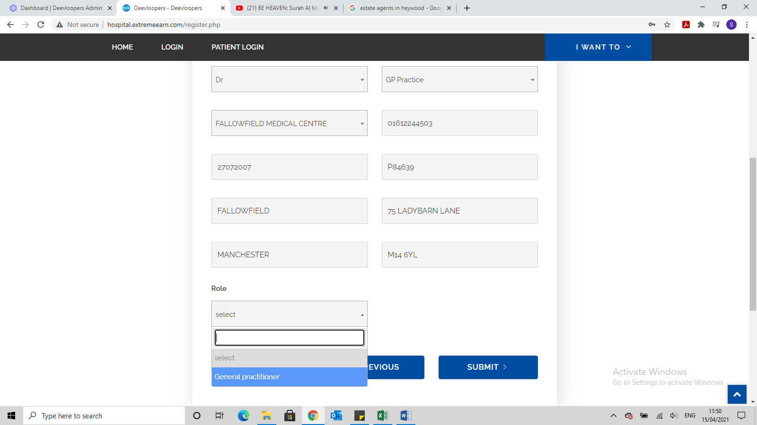

General practitioner needs to be General Practitioner

Also once registered the page needs to revert back to Home page

It needs to bring the Patients First Name, Last Name, email address and Password to this page, so they can double check it before submitting.

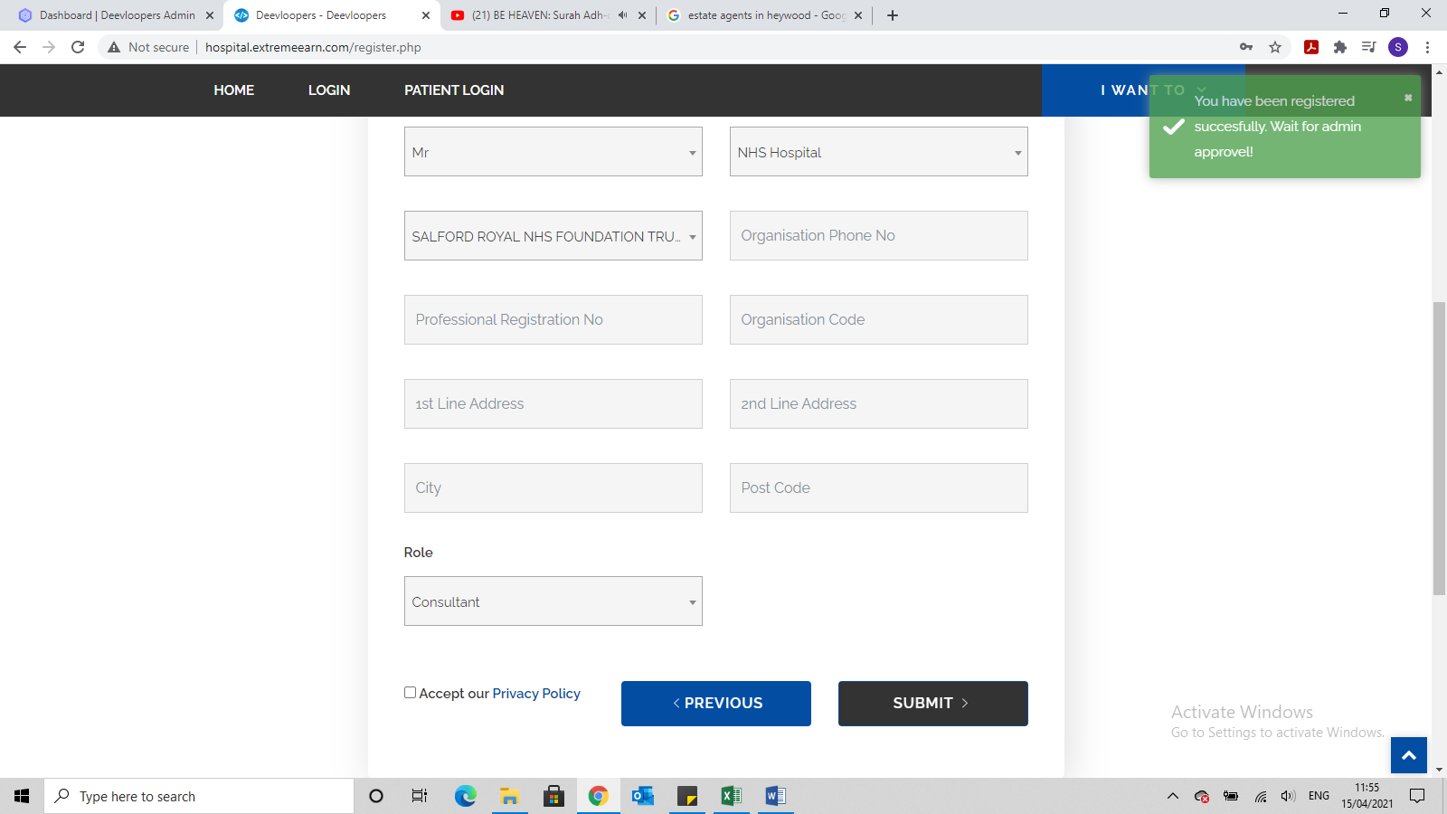

The confirmation message in green need to appear in the middle of the screen and there is incorrect spelling. Please change to

*You have been registered successfully! Please wait for admin approval*

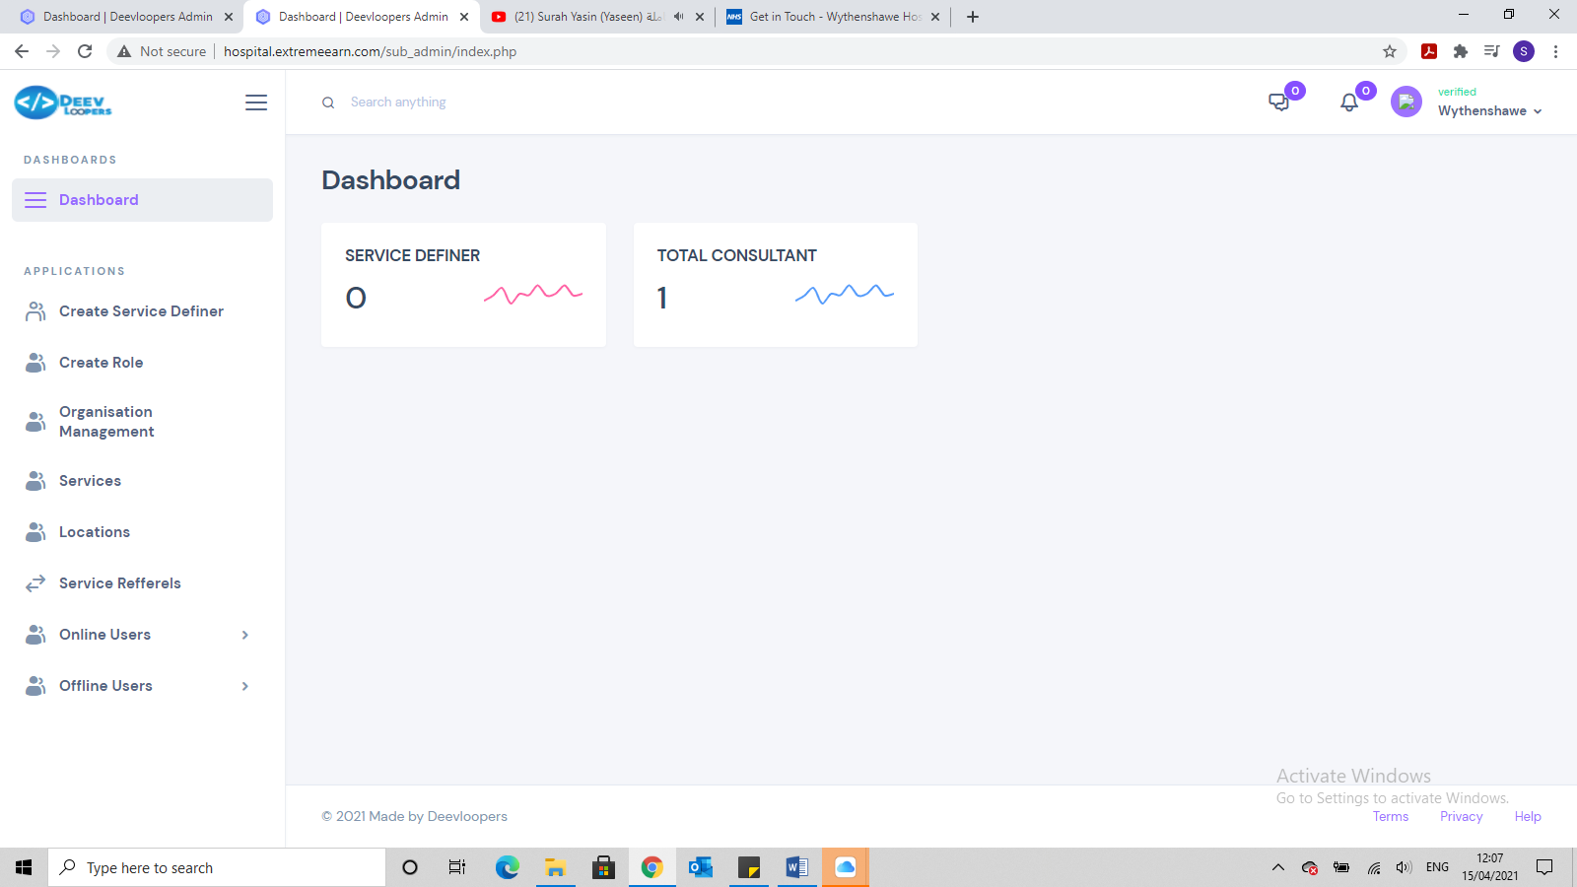

I have just created this organisation but it states there is a Consultant registered but I haven’t registered any consultant for this hospital, as u can see from the picture below.

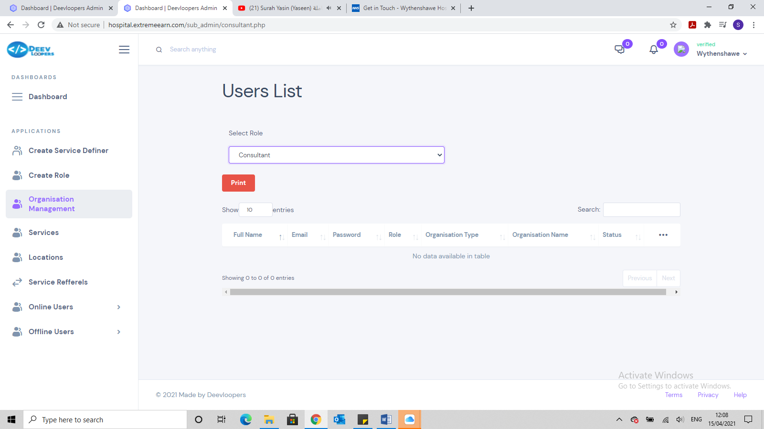

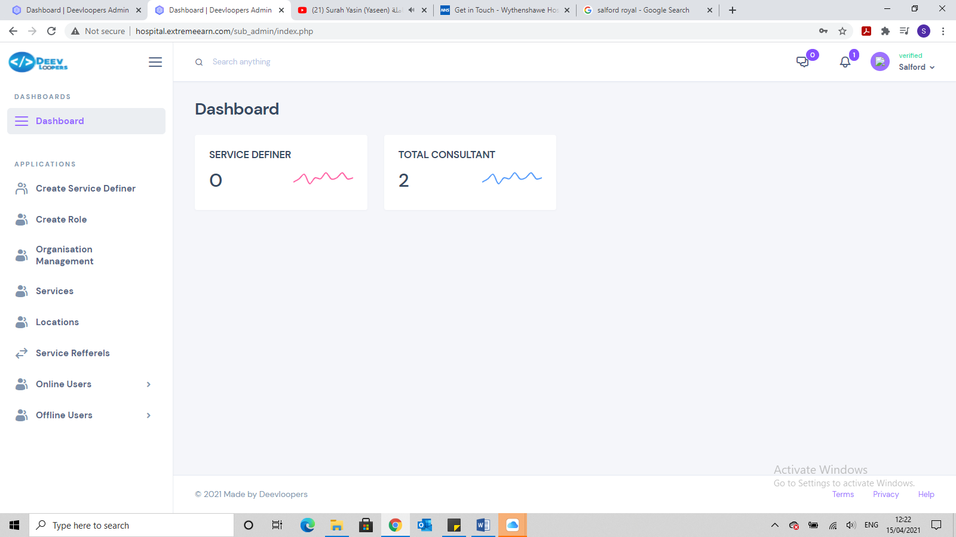

This hospital is showing 2 consultants, but I have only setup 1 for this hospital

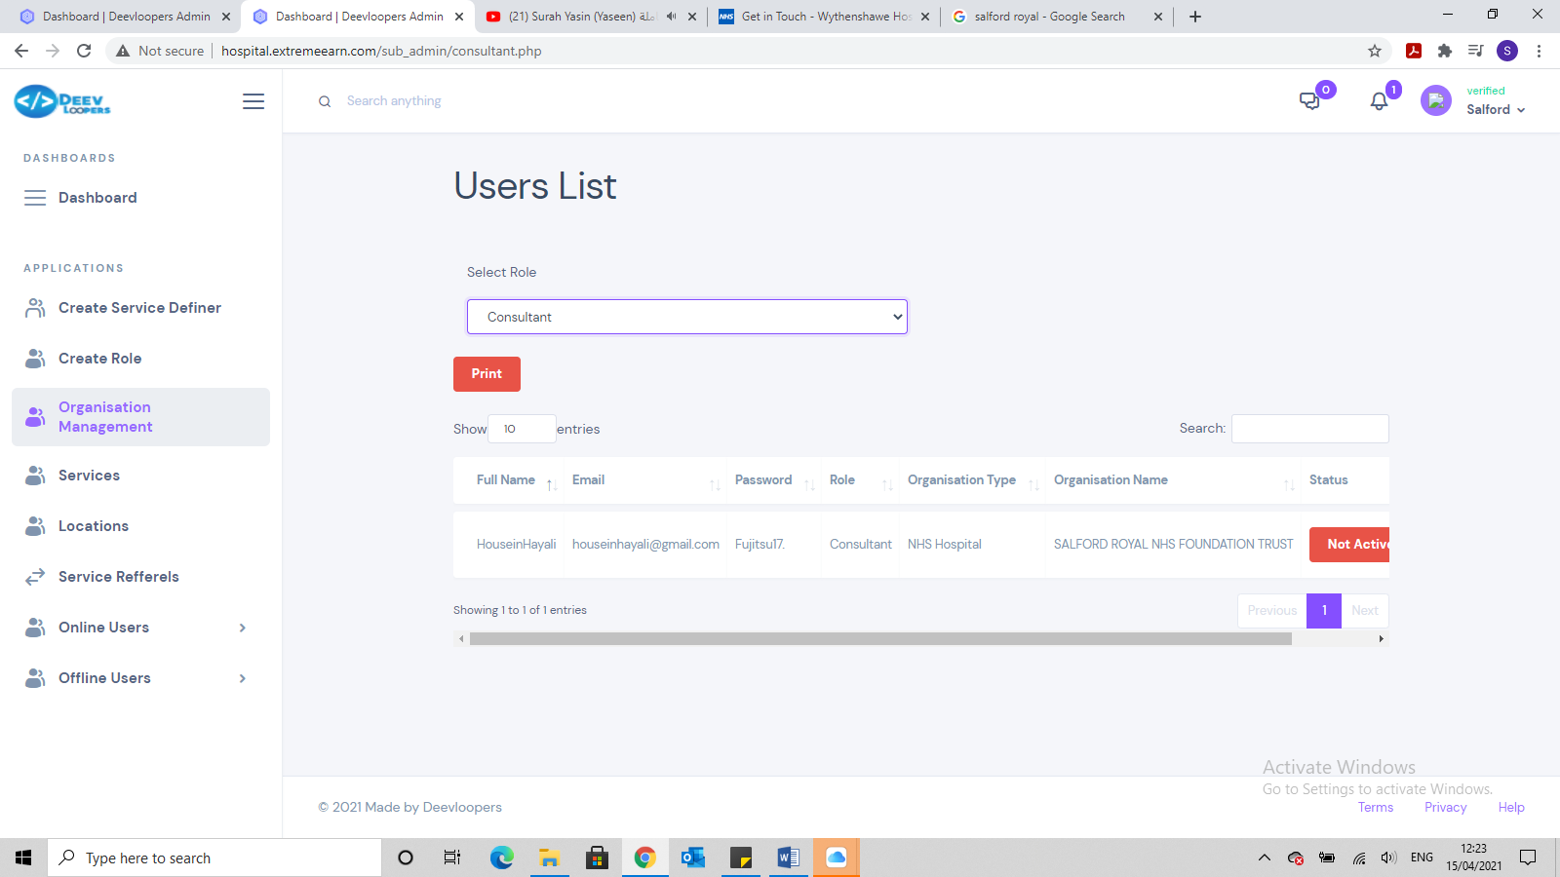

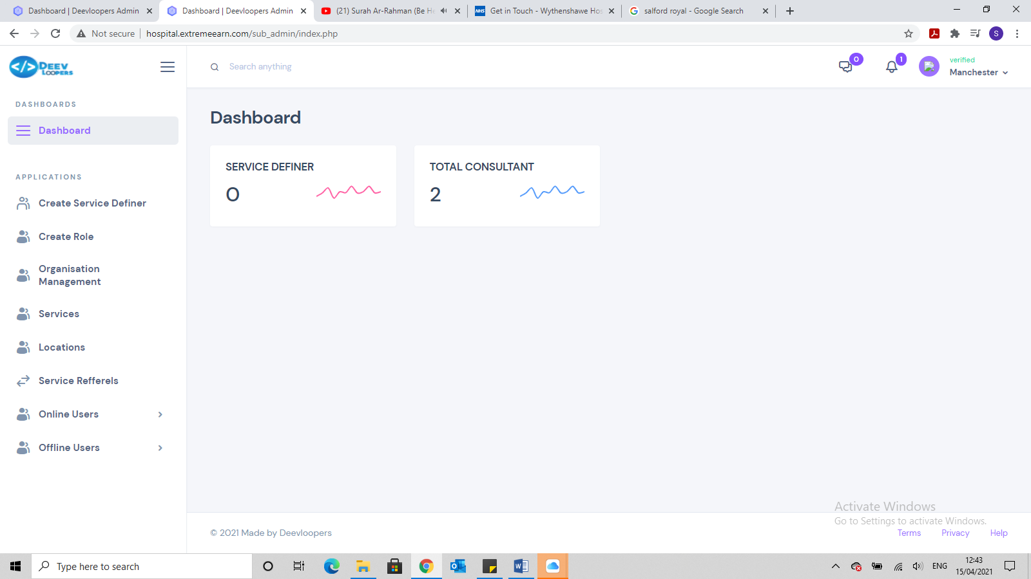

This hospital is showing 2 consultants, but I have only setup 1 consultant for this hospital, see below.

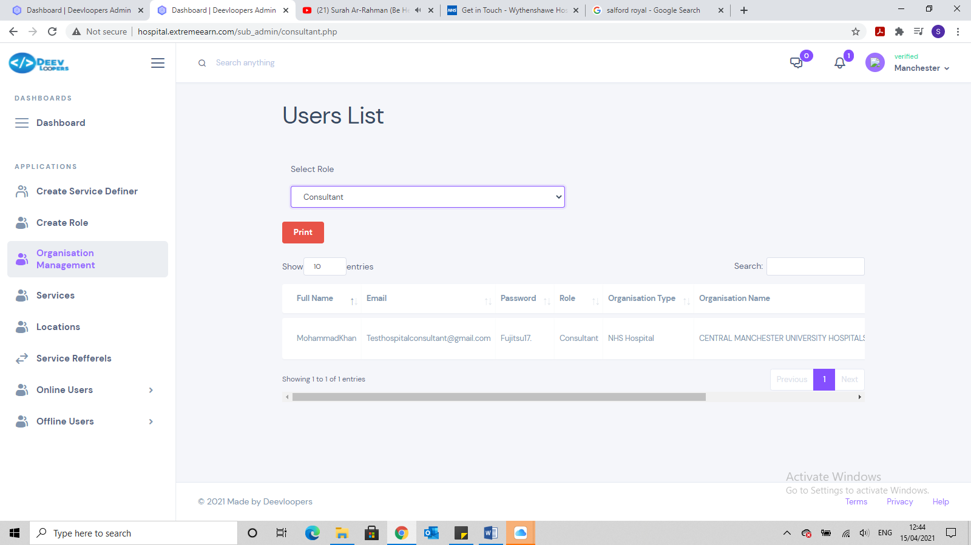

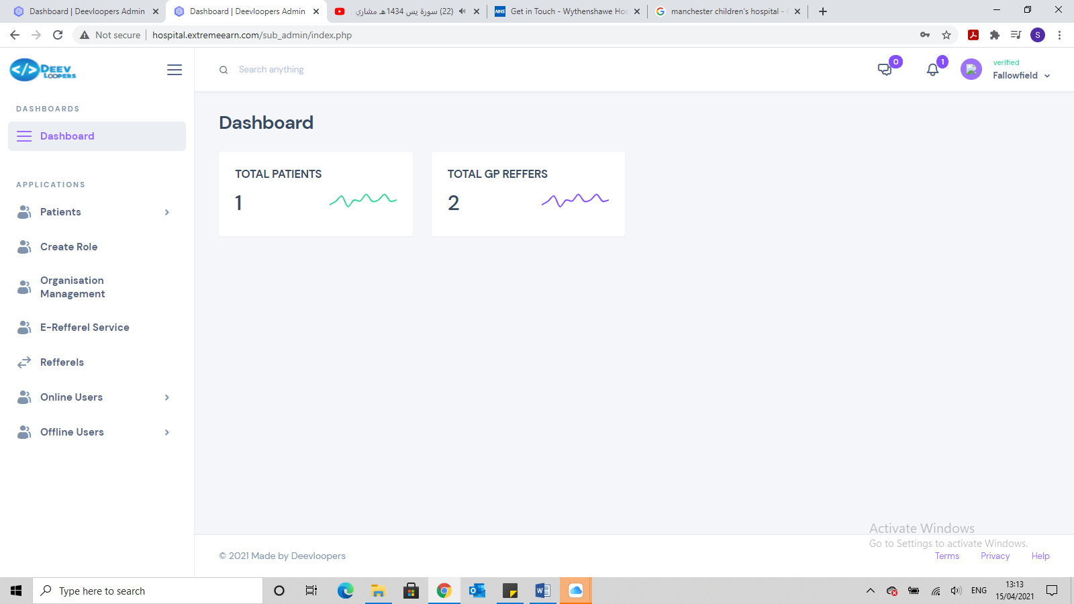

This GP practice is showing 2 consultants and 1 patients, but I have only setup 1 GP and 0 patients for this GP practice, see below.

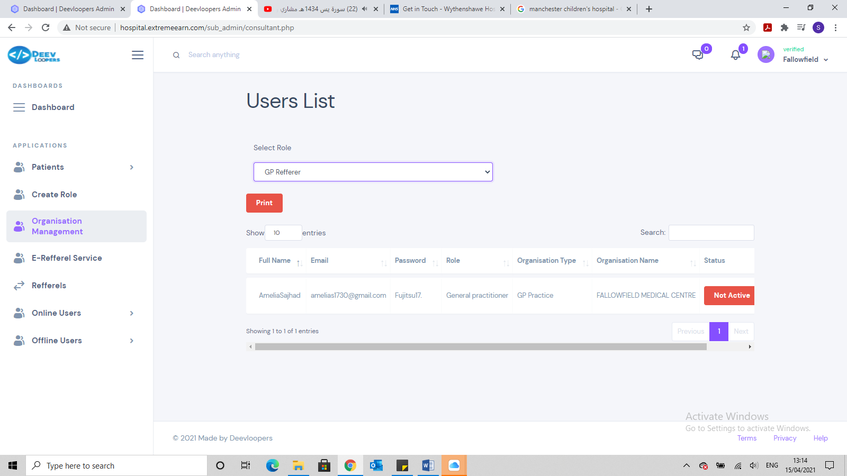

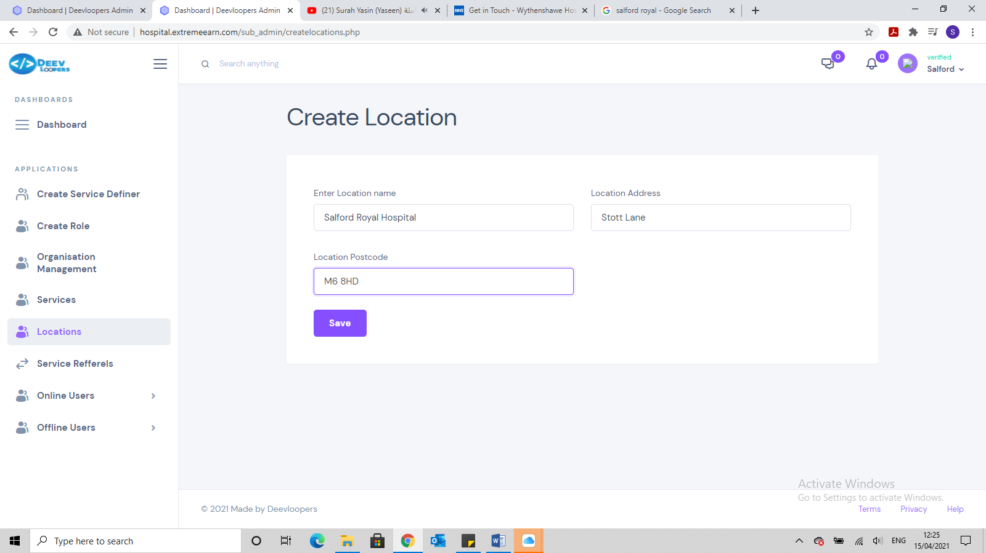

We need First Line address, Second Line address, City, Post Code

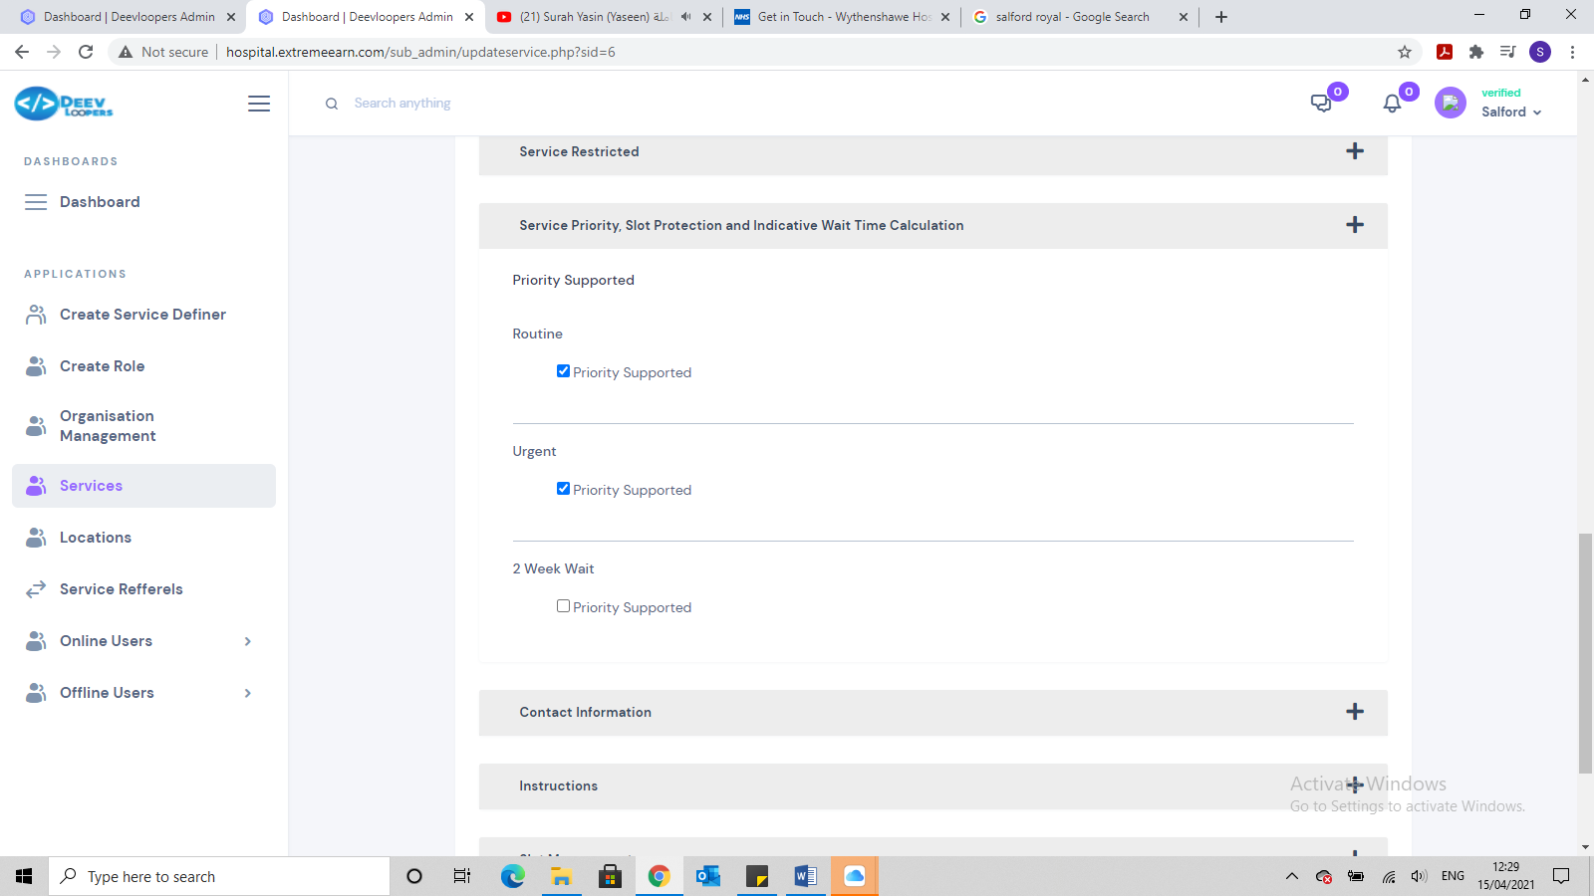

Once you have saved a service and go back into I to Edit, the number of days disappears and the exclude weekend disappears.

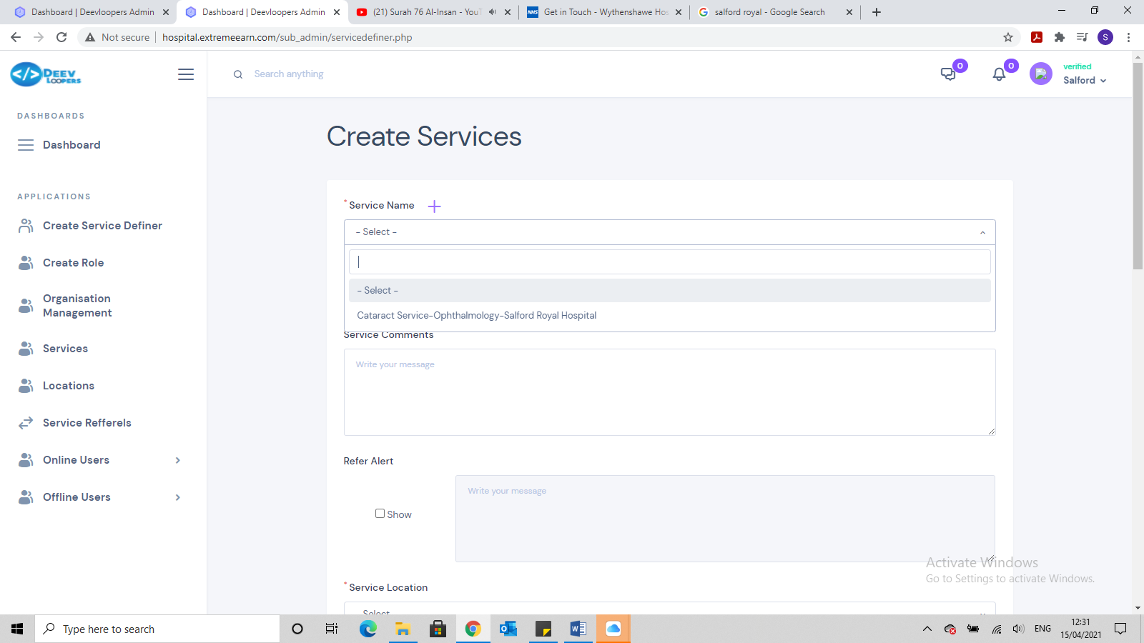

When creating a new service existing service names should no be available as a drop down option.

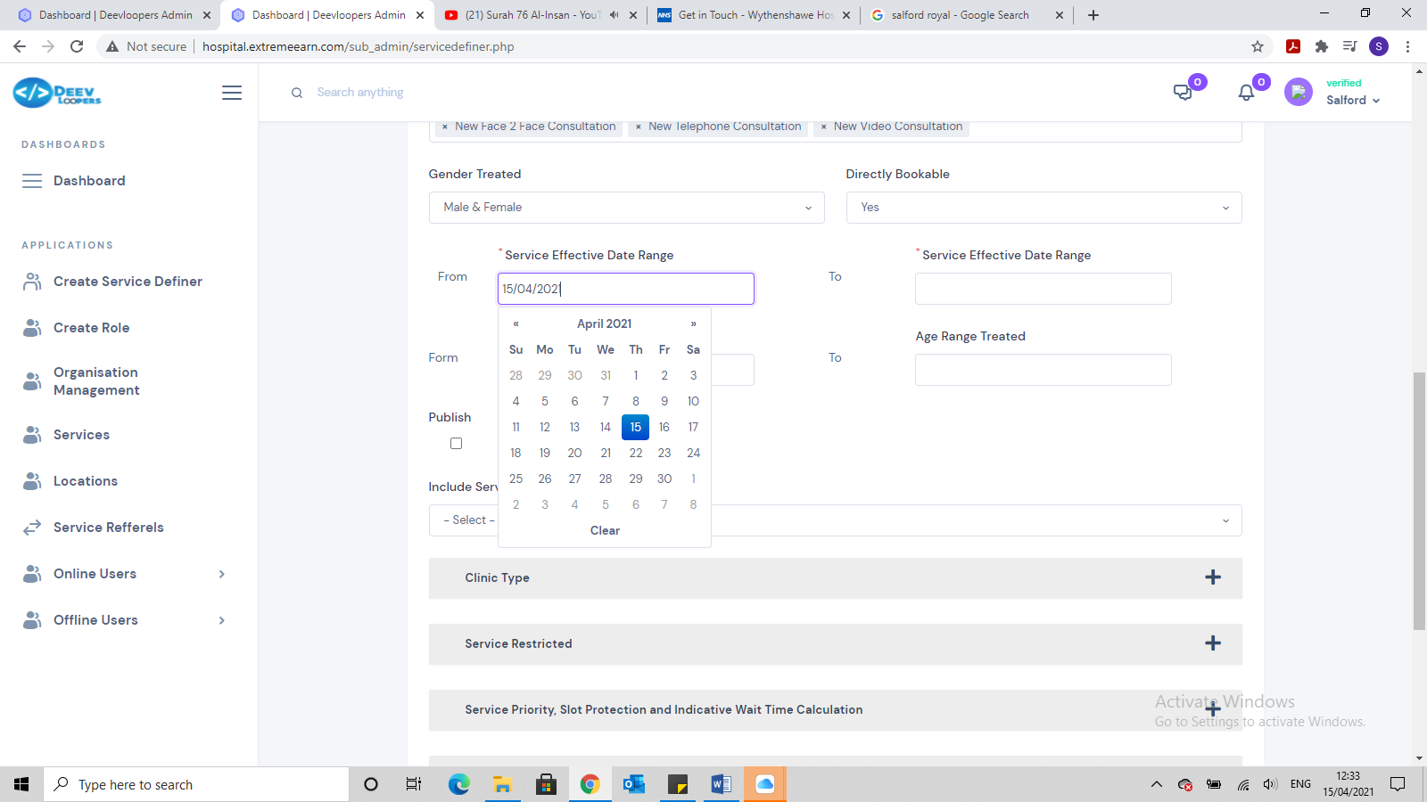

When selecting a date, the calendar doesn’t disappear, you have to click on another part of the page and then it disappears.

If not all fields are completed and it states ALL fields must be completed, when trying to save, can you turn the mandatory parts that are not completed RED, so its easier for the user to know, which fields still need completing.

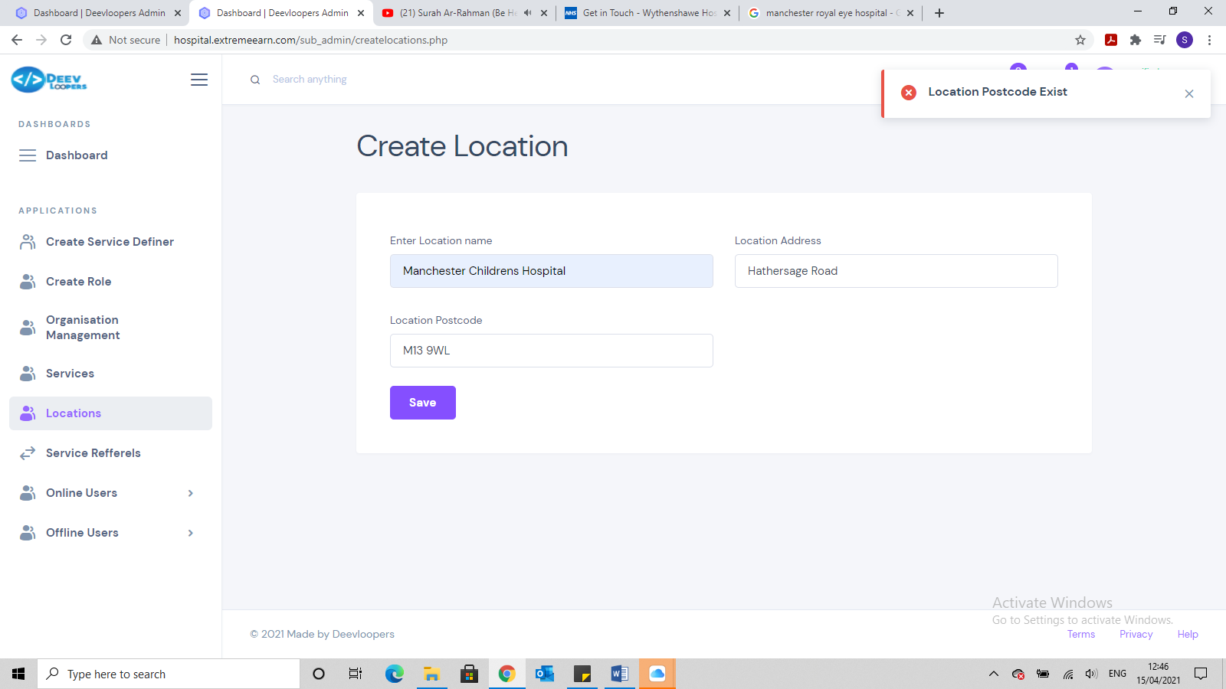

I am trying to setup 2 locations within Manchester Hospital with the same post code but it wont let me. This should be allowed.

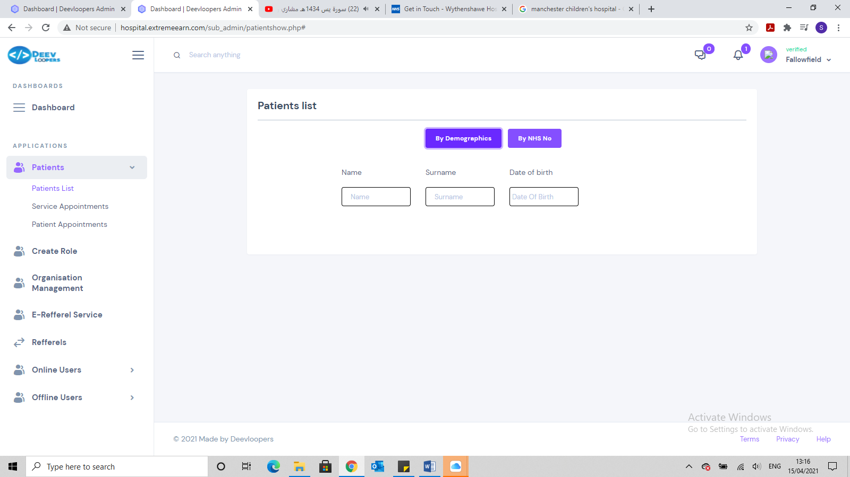

Can the patient search facility be more dynamic. So we can search for patients by putting in just D.O.B or just first name or just Last name (also please change everywhere where it states surname or Last name). So if I type in Ahmed, ALL patients with last name Ahmed are listed.

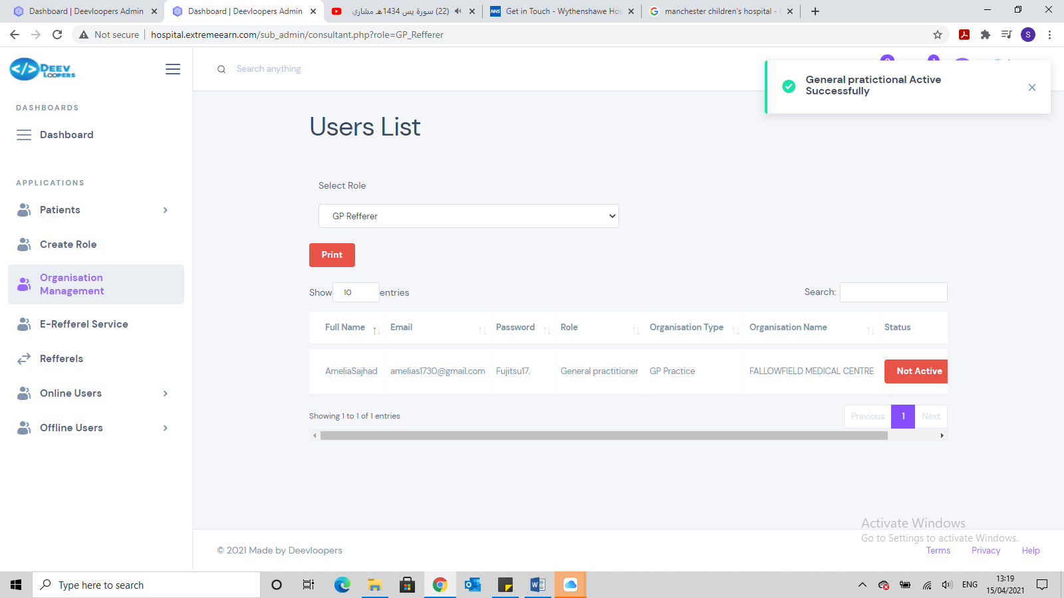

The message when activating the GP needs to be reworded to

User name account activated successfully e.g, ***Amelia Sajhad account activated successfully (this is partially completed, need the full name to be stated)***

This need to apply to all users, Consultants, Optometrists etc etc.

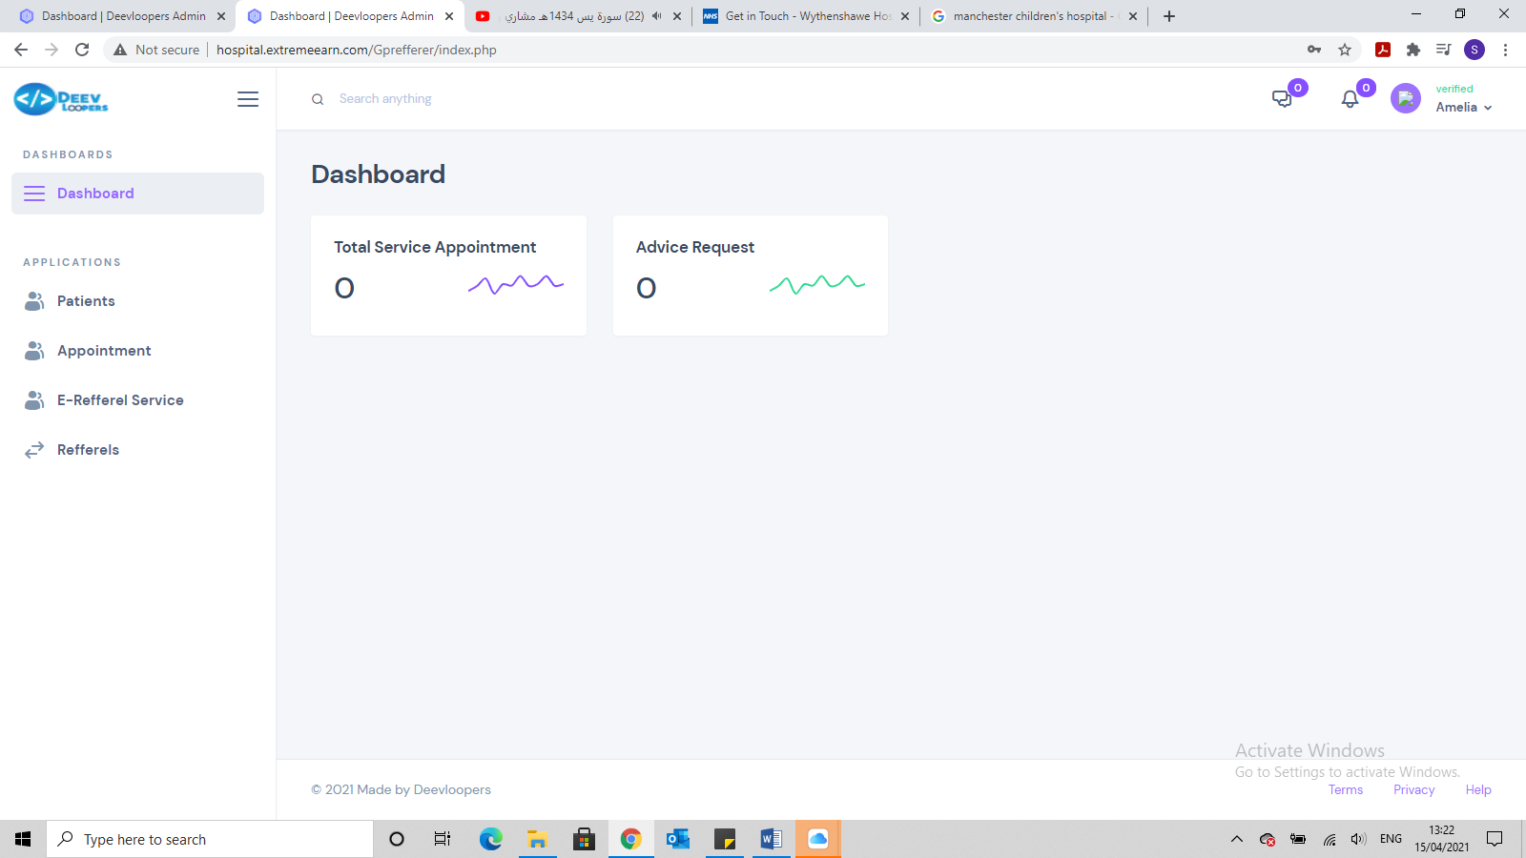

This page to have:

* Total No. of Referrals Sent
* Total No. of Referrals Accepted
* Total No. of Referrals Rejected
* Total No. of Appointments NOT Booked

And we should be able to click into them and it will provide a list of all the appointments not booked or shows the number of referrals sent etc.

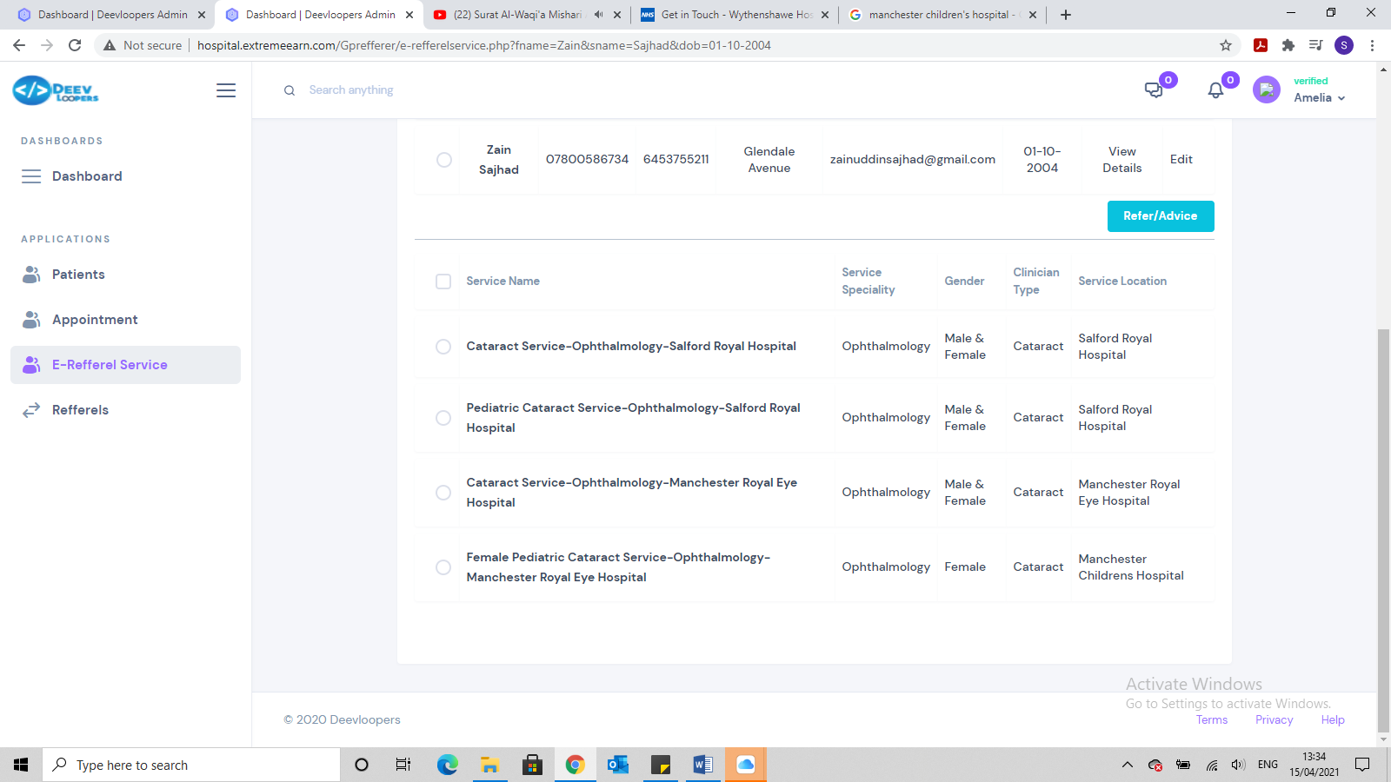

This is a 16 year male patient I am referring but along with the correct service there are 2 services that should NOT be coming available because:

* 1 is Child service for patient age from 0-15
* 2nd one is also child service but also female only service.

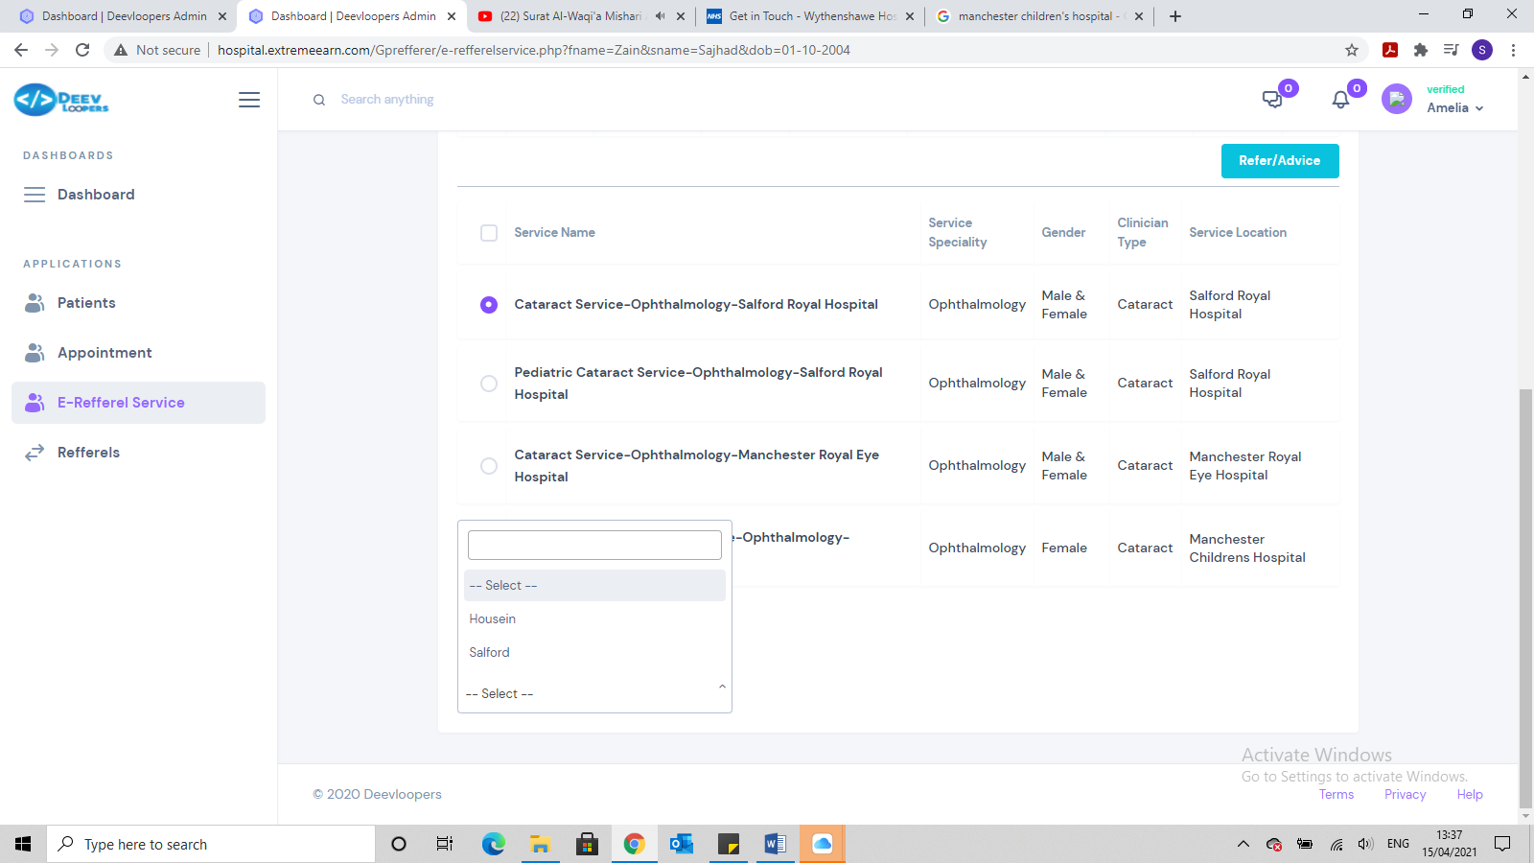

We are getting the hospital as an option as a Consultant. Salford is the hospital and shouldn’t be available under consultant.

I think we need an option, when creating the service to allow for the Consultant to be linked to that service and that way it would be more connected and specific.

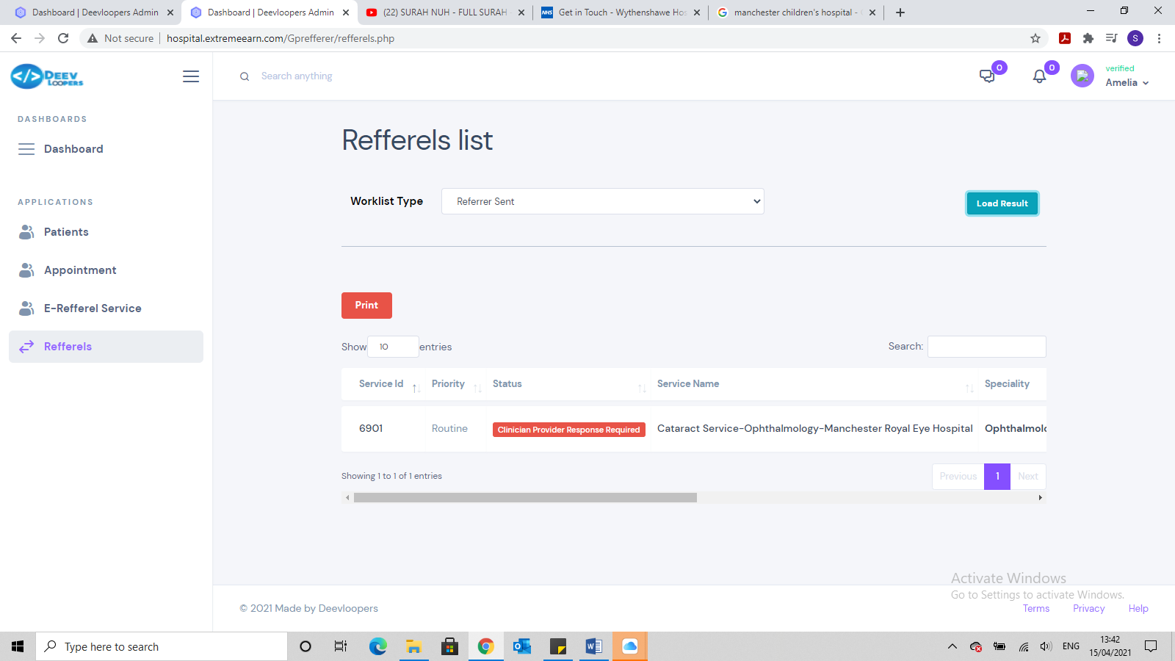

Where it states service ID, this should state the unique referral number. Also the design is not very user friendly, too much scrolling. We need to design it better. Can we have the following heading:

Referral ID:

Priority:

NHS No:

Patient First Name:

Patient Surname:

Speciality:

View Referral:

Book appointment:

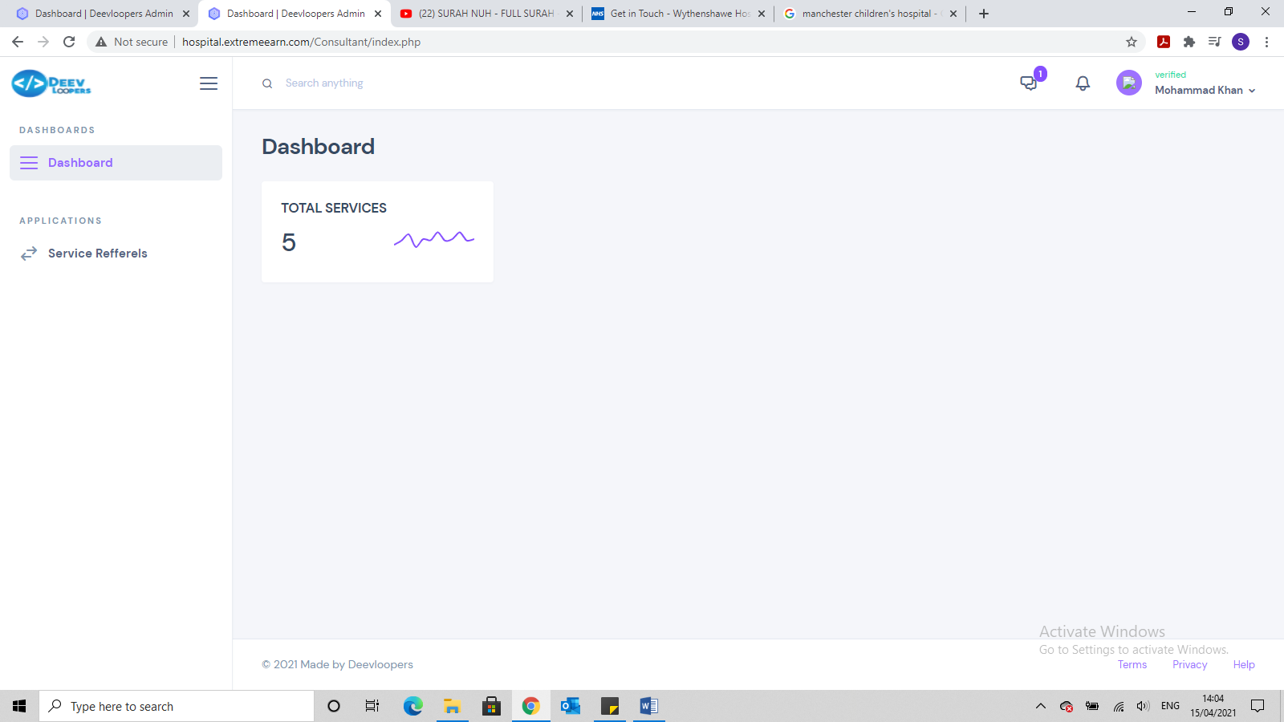

What does this Total Service Refer too?

Can you replace dashboard with the following (which should all be clickable and have the number of new requests / referrals in bracket:

Urgent Advice Request (5)

Routine Advice Request (2)

Urgent Referrals Awaiting Triage (10) (*please change Referrals received to Referrals Awaiting Triage*)

Routine Referrals Awaiting Triage (20)

These 4 should be at the top going across the page

And then the following going across underneath them 4

* Advice Requests Responded
* Referrals Accepted
* Referrals Rejected

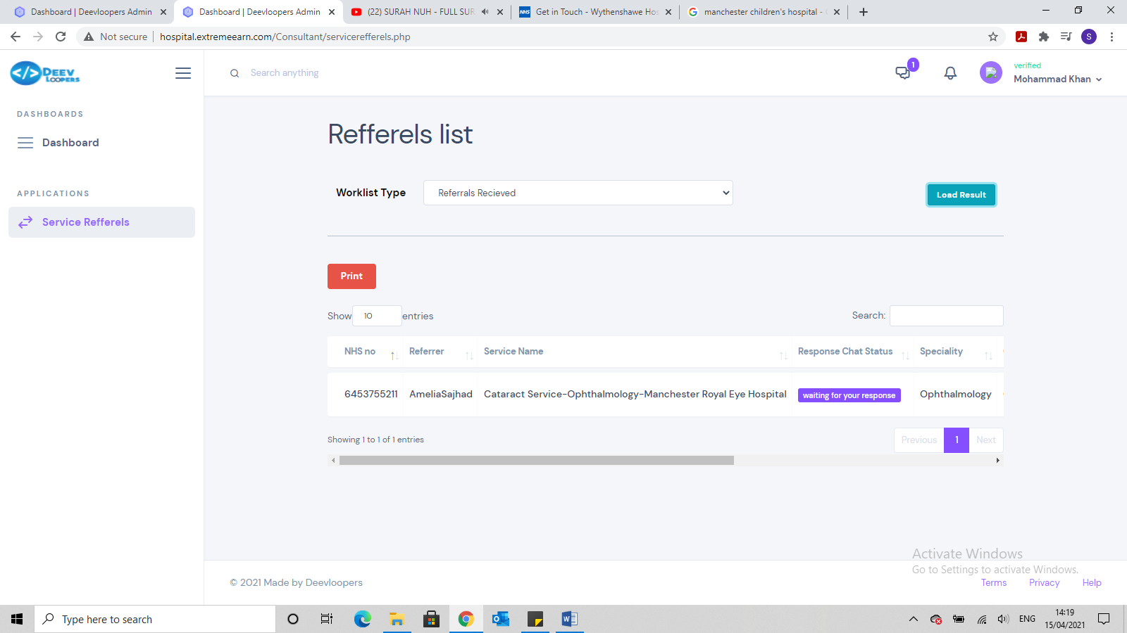

Too much scrolling, needs to be redesigned.

The headings should be:

* Referral ID
* Date Referral Received
* NHS No
* Patient First Name
* Patient Last Name
* D.O.B
* View Referral

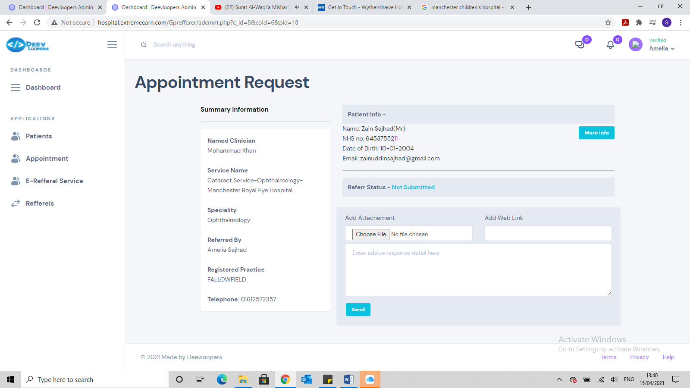

When logging in via the GP who referred this patient, there is no comments or the attachment (see above picture) but when logging in as the consultant it shows the comment and attachment (see below picture)

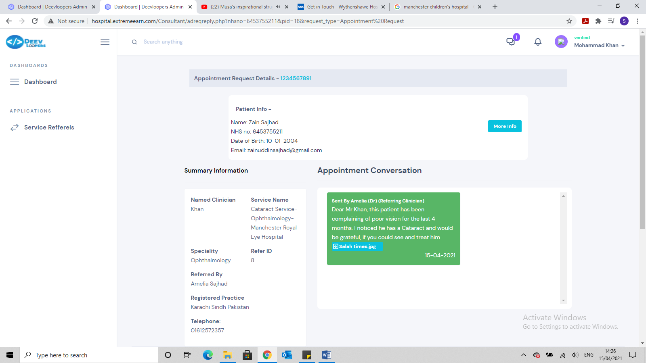

* You will also notice the GP picture shows Practice as Fallowfield Medical Centre, which is correct but the Consultant page shows Karachi Sindh Pakistan.
* Consultant Name should be full, Mr Mohammad Khan not just Khan
* There should also be an option to print the referral, into a PDF, which should have the following included:
  + Referral ID
  + NHS No.
  + Patient full name
  + Patient D.O.B
  + Patient full address
  + Speciality and clinic type the patient was referred too
  + Referrers full name
  + Referrers full address
  + Referrers phone number
  + Any text the referrer has sent
  + Also to print any attachments

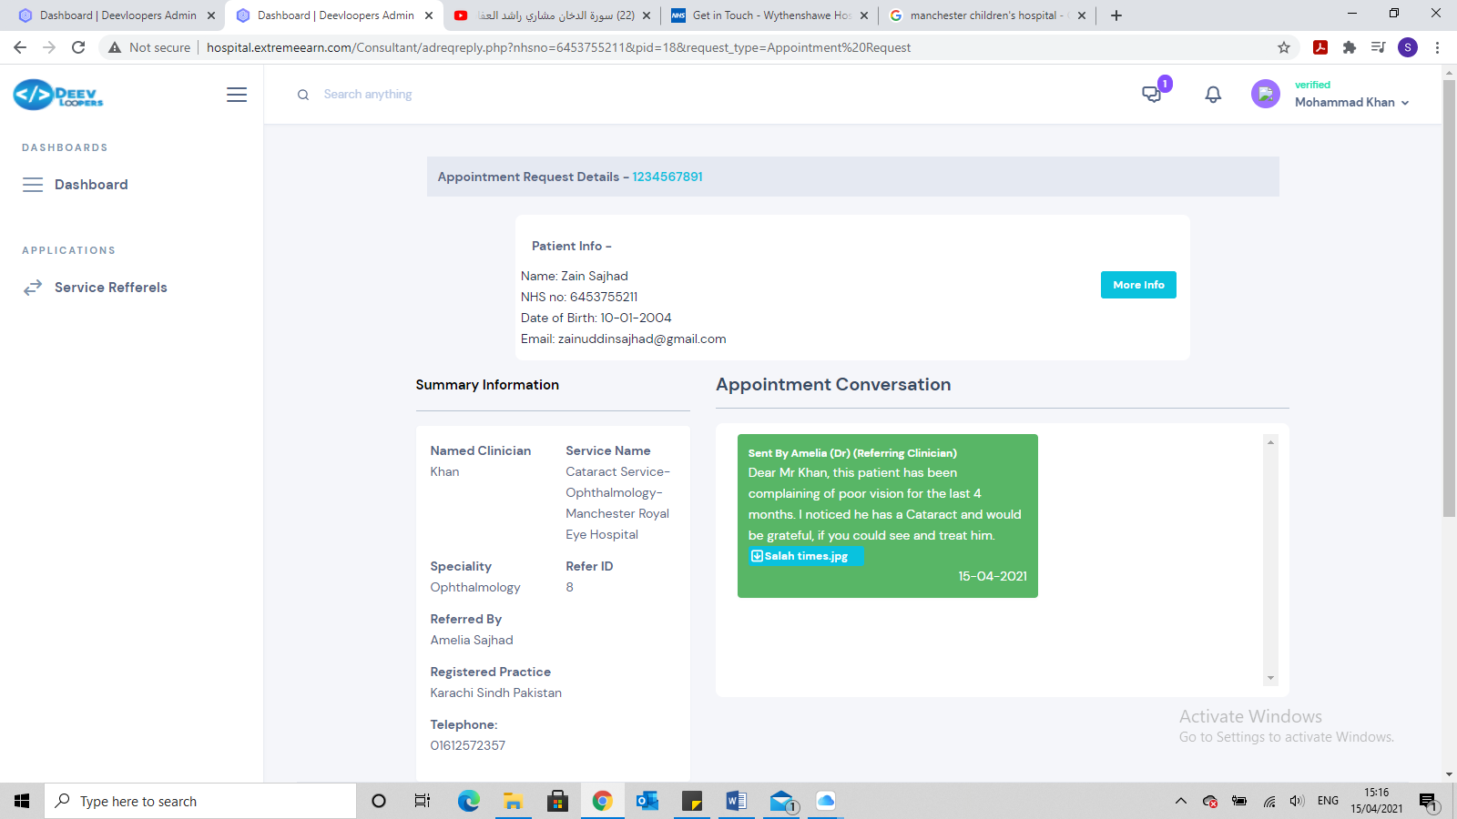

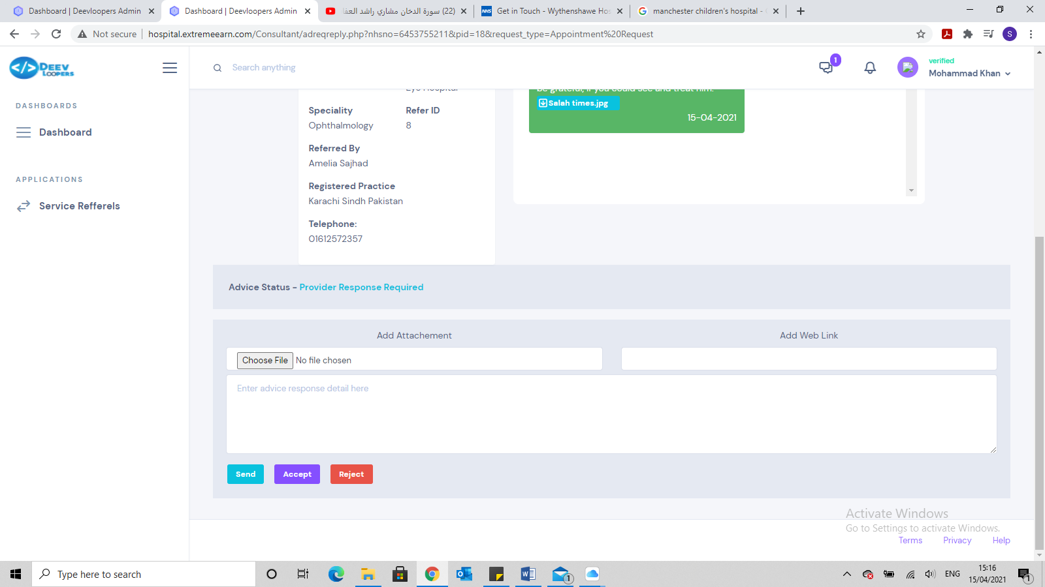

We need to redesign this page, as its too much scrolling.

Also we don’t need ***Send*** button on referrals, only on Advice requests. On referrals we should only have Accept, Reject or redirect. Redirect would give the Consultant the option to redirect the referral to another consultant within the hospital.

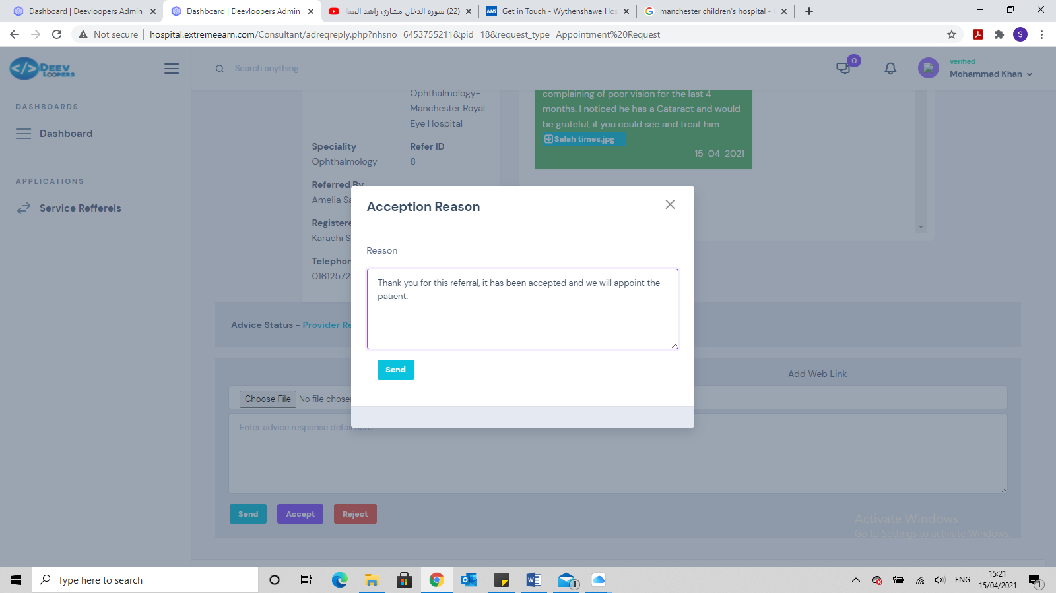

Once the referral is accepted, it needs to go back to the Dashboard page

**Saturday 17 April 2021 Testing**

* Organisation registration page has too much scrolling, needs to be redesigned, so less scrolling

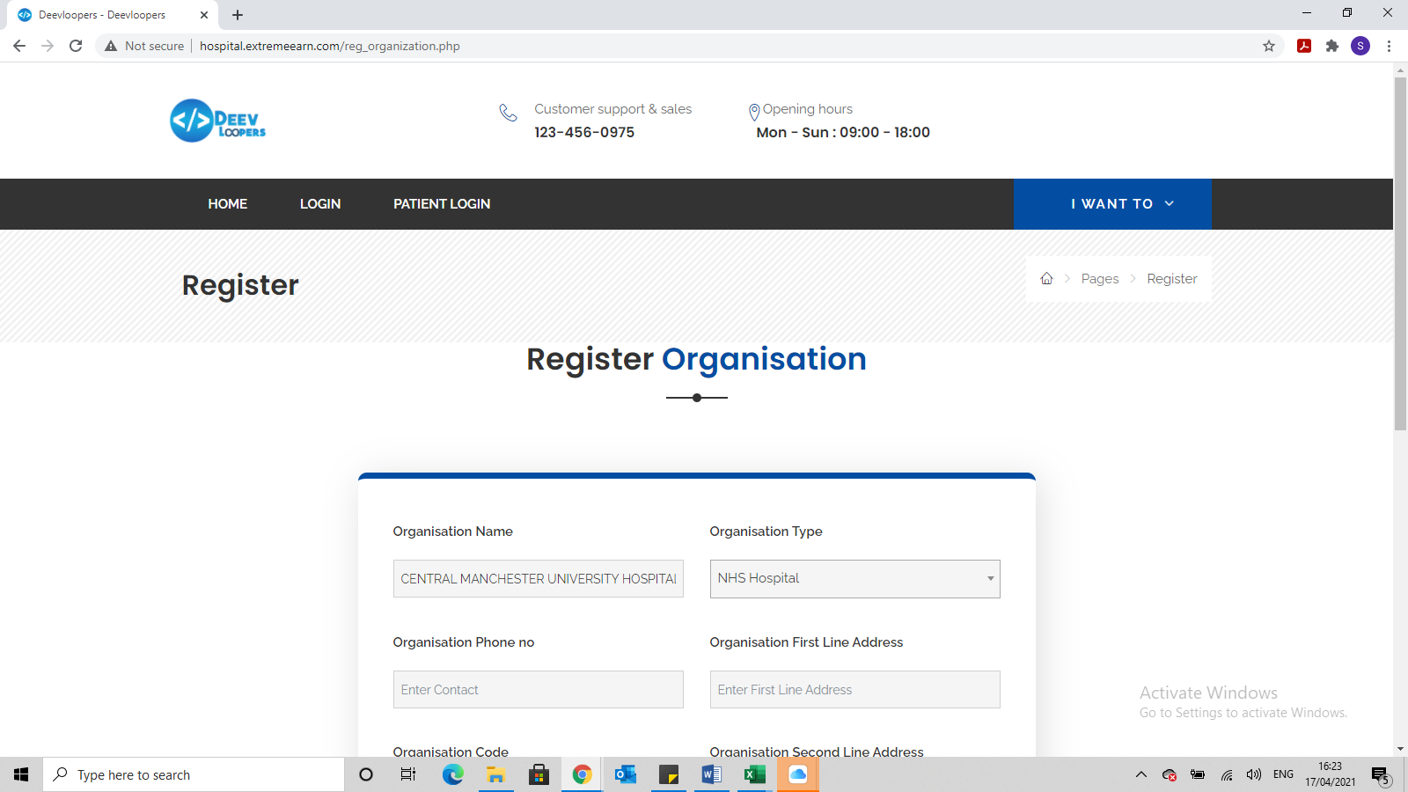

* Register Yourself page has too much scrolling, needs to be redesigned, so less scrolling. Also remove the word ***Get***

Registration email needs to be reword to:

Dear (name of registered person)

Thank you for registering on the Referral System.

The details will be reviewed by admin before it is approved.

You will receive an email, once it has been approved.

Regards

The Referral Team

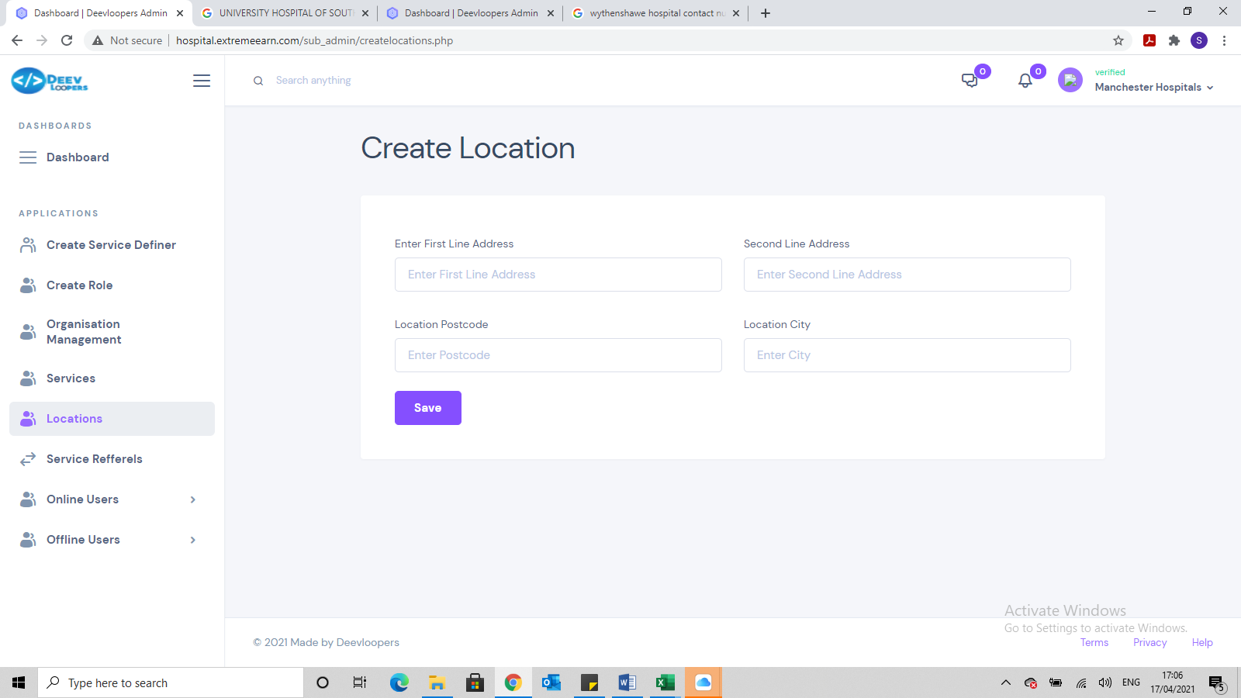

New location needs to have the following added:

* Location Name
* First Line Address
* Second Line Address
* City
* Post Code
* Site Code

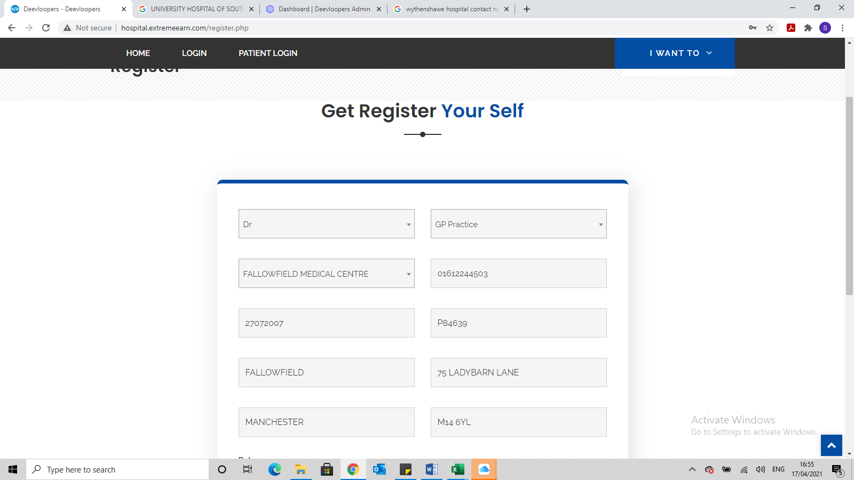

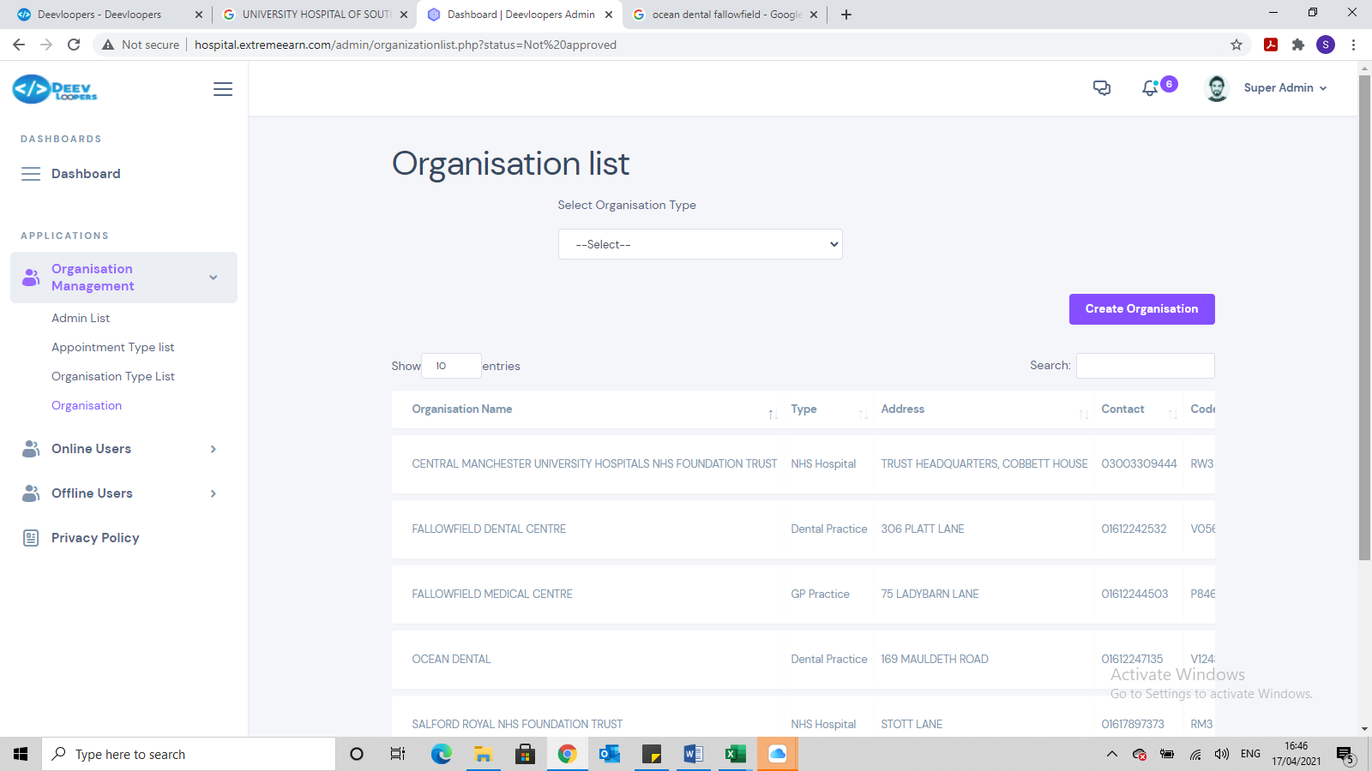

Super Admin page will need to be redesigned, as too much scrolling

Sunday 25 April 2021

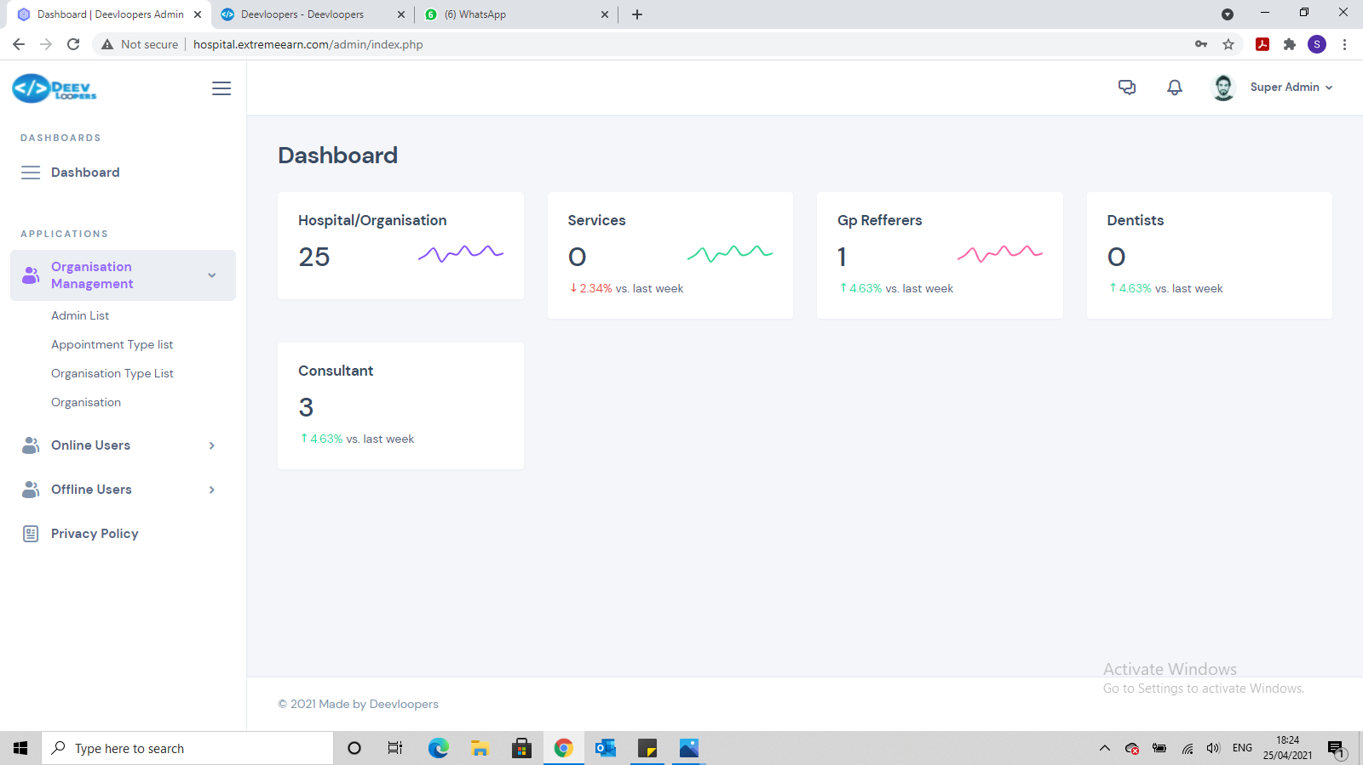

We need to develop this page better, so we can see and click on:

* Hospitals
* Dentists
* Opticians
* GP Practices
* Services
* Consultants
* Admin

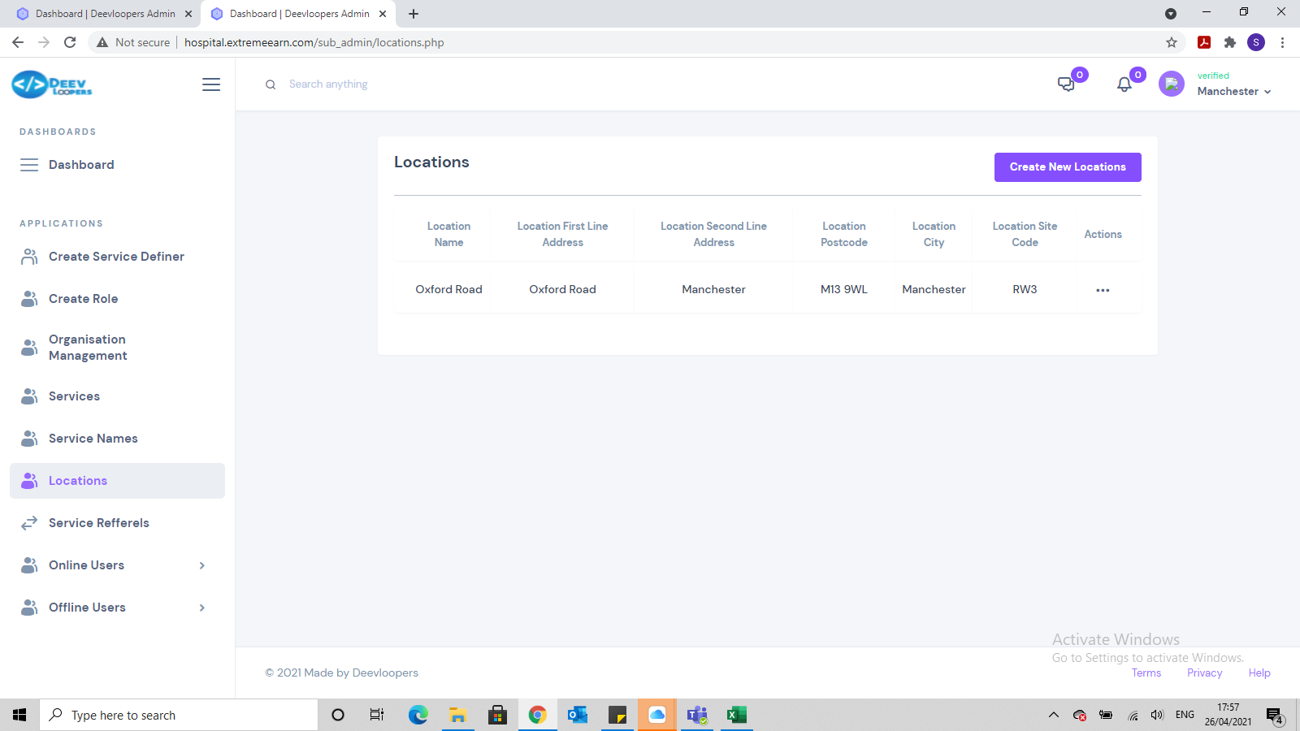



* It allows me to enter the same location code for the location and the Organisation. Location codes must be unique.

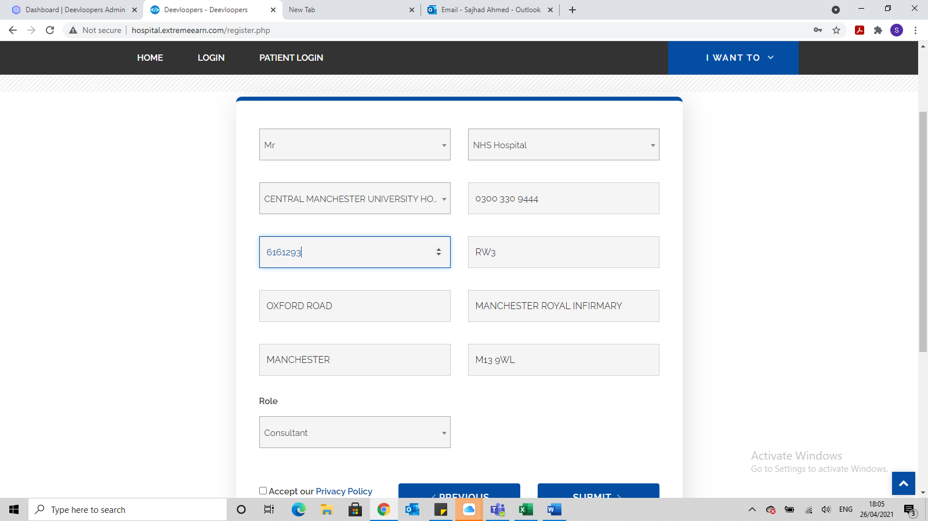

Can you add a drop down box called Registration Body and have the following options:

* General Practice
  + General Medical Council (GMC)
  + Nursing & Midwifery Council (NMC)
* Dental Practice
  + General Dental Council (GDC)
  + Nursing & Midwifery Council (NMC)
* Opticians
  + General Optical Council (GOC)
* Community Hospital
  + Admin & Management
  + General Medical Council (GMC)
  + General Optical Council (GOC)
  + General Dental Council (GDC)
  + Nursing & Midwifery Council (NMC)
* NHS Hospital
  + Admin & Management
  + General Medical Council (GMC)
  + General Optical Council (GOC)
  + General Dental Council (GDC)
  + Nursing & Midwifery Council (NMC)

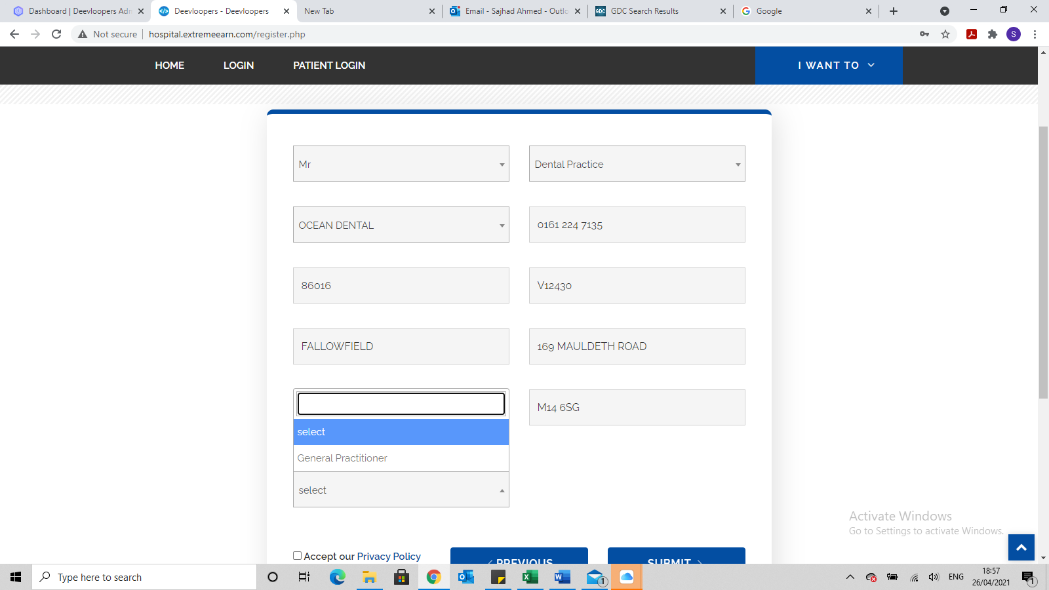

I was registering a Dentist but the option is General Practitioner…the options should be:

* Dentist

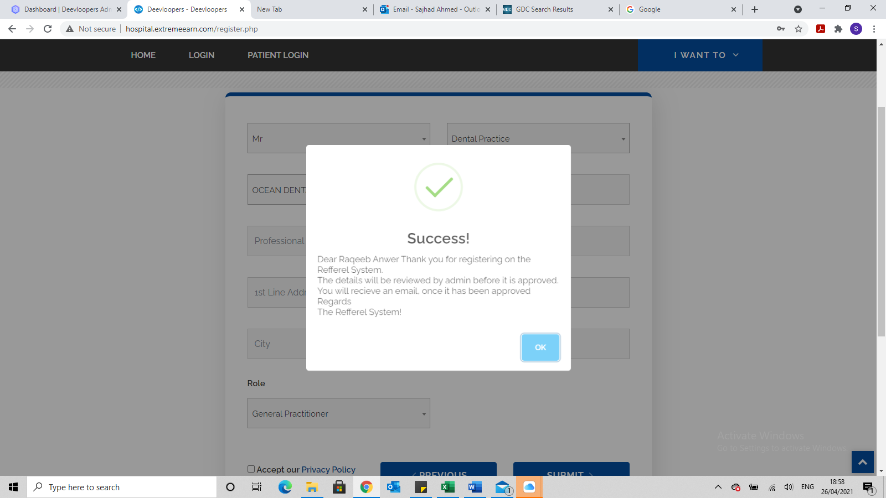

Please can the message me replaced with:

Dear (full name of person),

Thank you for registering.

The details will be reviewed by the admin team, before being approved.

You will receive an email once the registration has been approved.

Regards

Referral Team

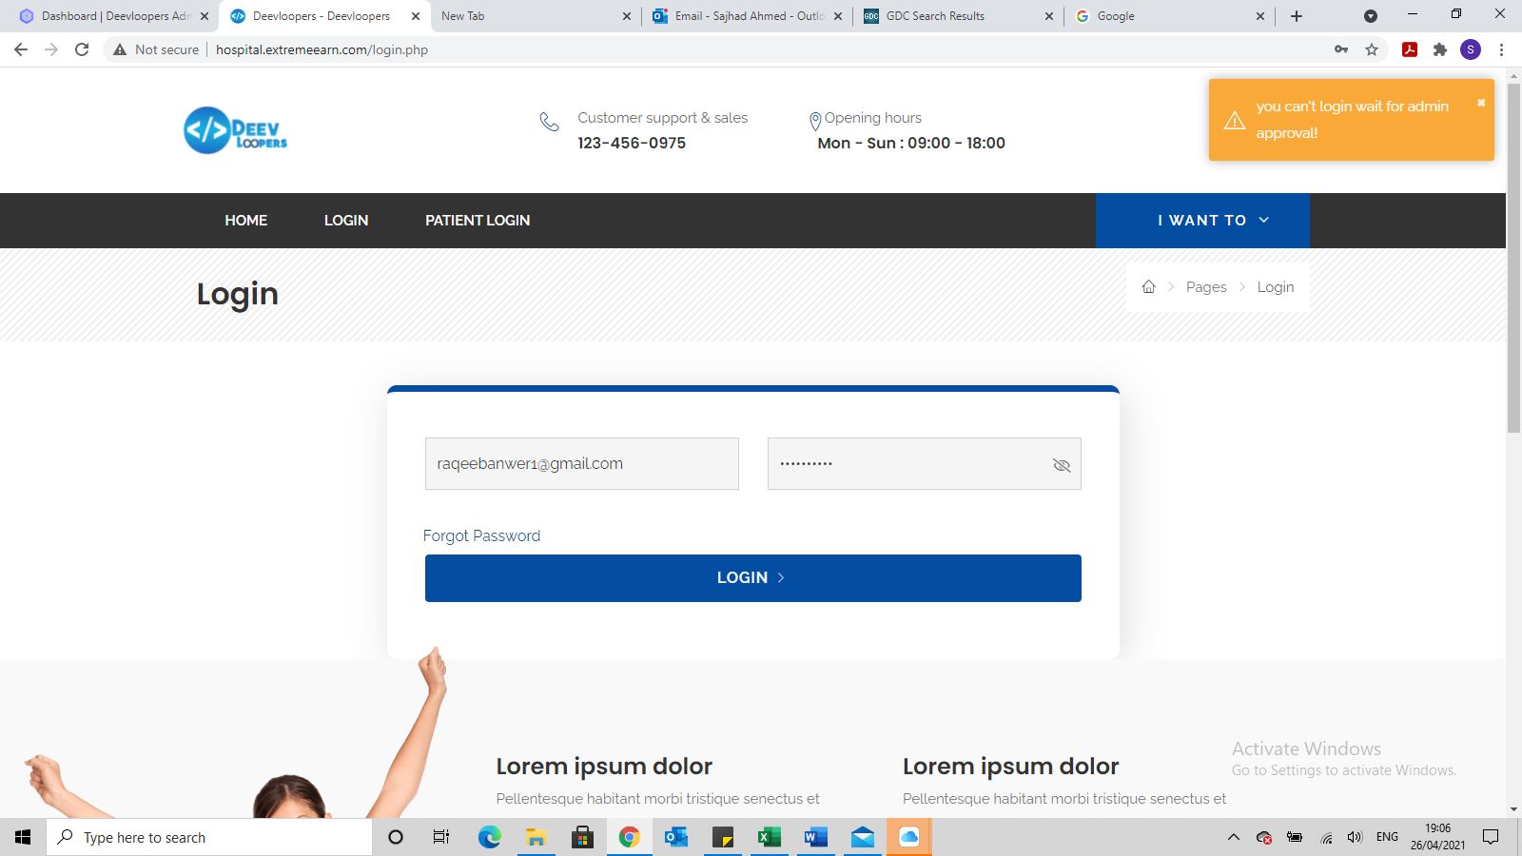

Please can the message in orange come to the middle of the page and say:

* Unable to validate details, awaiting admin approval

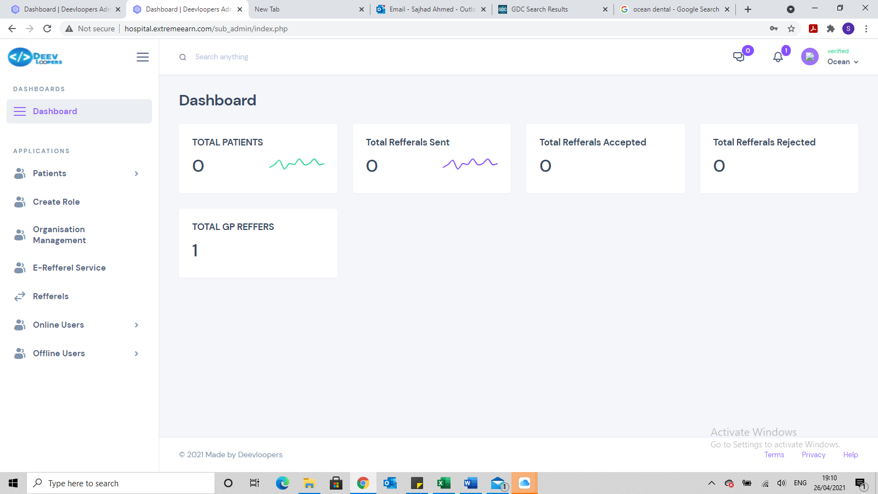

Please change the following:

* TOTAL PATIENTS to Total Patients Referred
* Total Refferals Sent to Total Referrals Sent
* Total Refferals Accepted to Total Referrals Accepted
* Total Refferals Rejected to Total Referrals Rejected
* Total GP Reffers to Total Registered Dentist

Also we should be able to click on this and they should go to the correct page. For example, if I click on Total Referrals Sent, it should show me a list of ALL referrals sent by all dentist from this organisation. This should apply to the other heading too.

Remember this is logged in at the practice admin level and so can see everything. If it was logged in as Dentist level, then the dentist can ONLY see the referrals he has made.

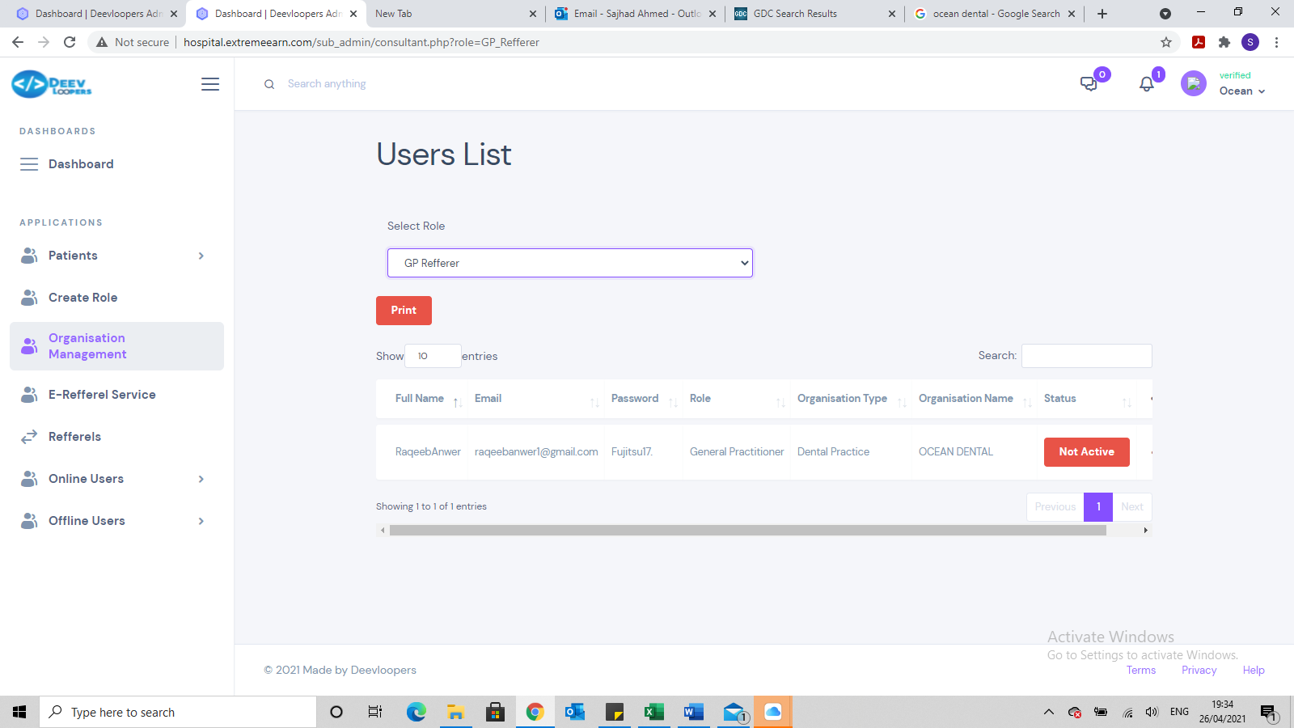

The drop down should be:

* Dentist

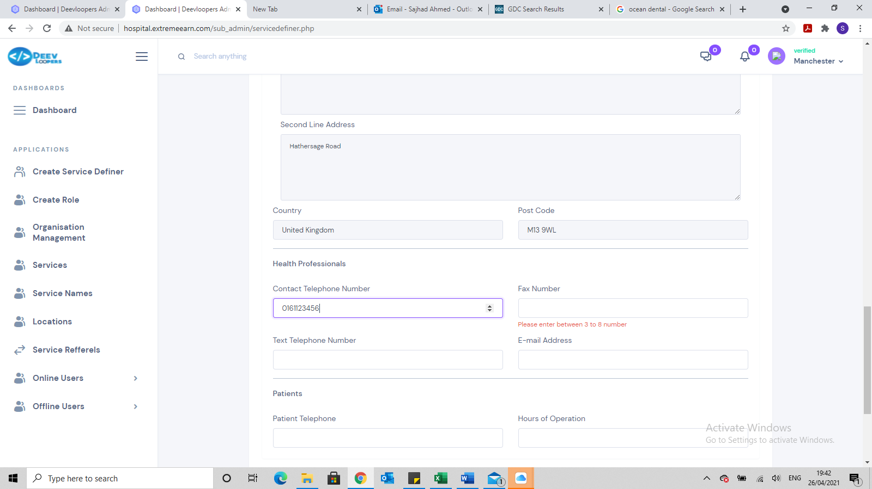

The restriction needs to be increased. Do same as Contact Telephone Number.

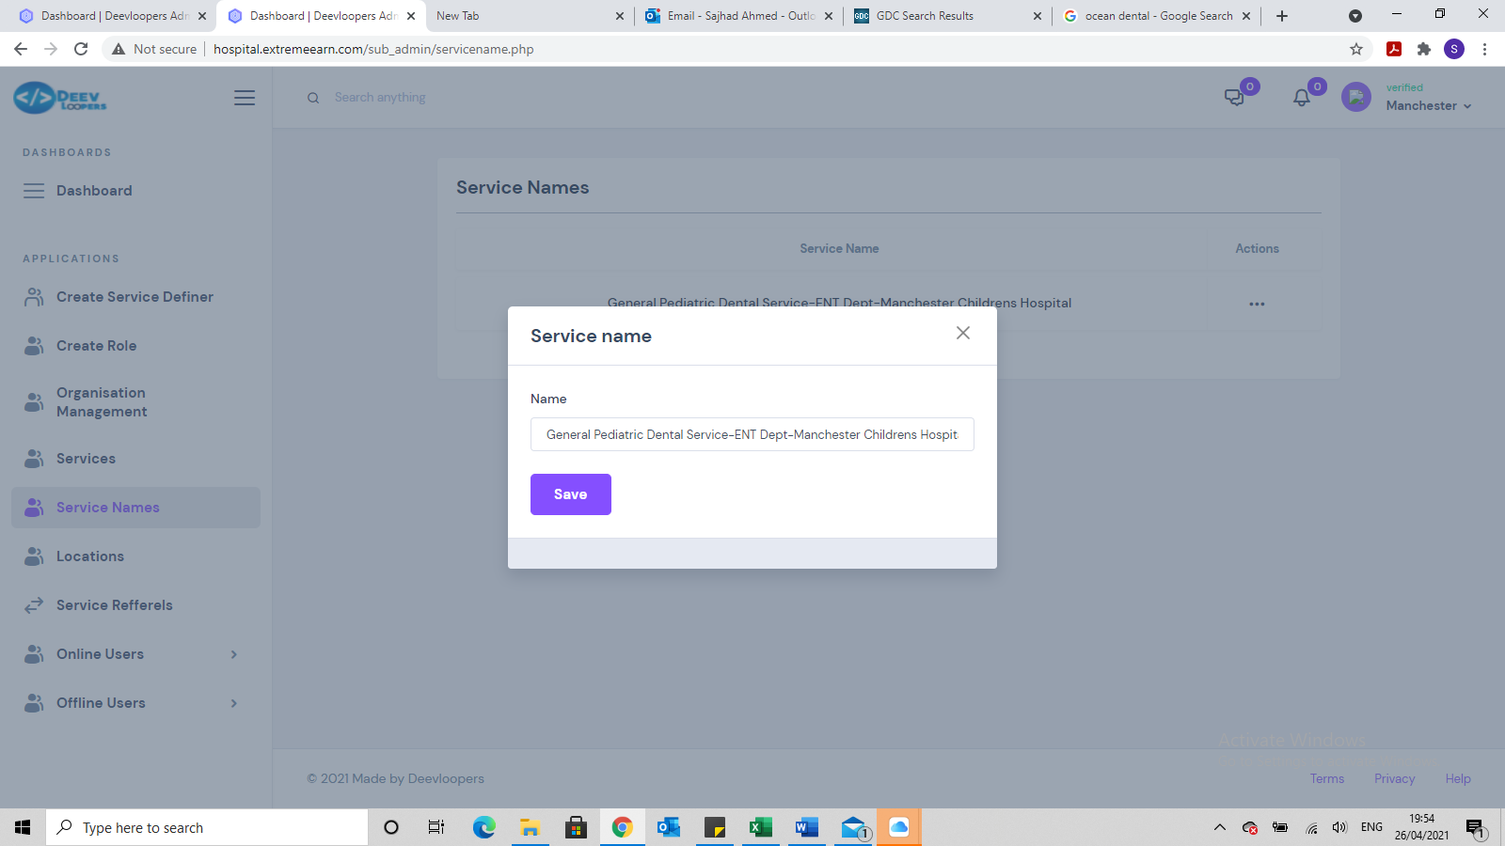

Need to be able to edit the entire service not just the name.

Also we don’t need Services and Service Names, just 1 will do and we should be able to edit from there.

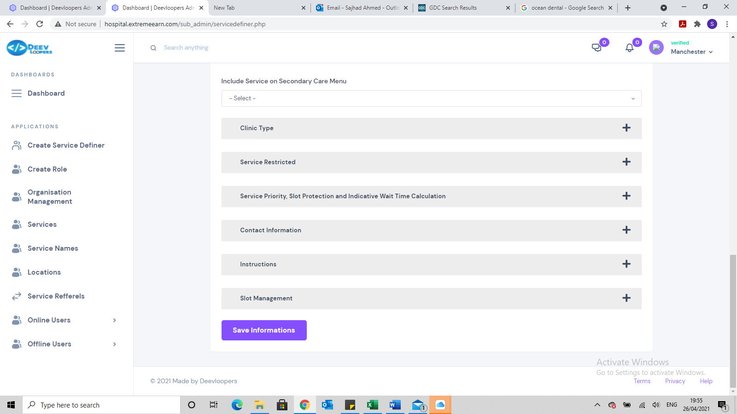

Need a Cancel button and once clicked on, it should say ***Are you sure you want to Cancel, the details will not be saved?***

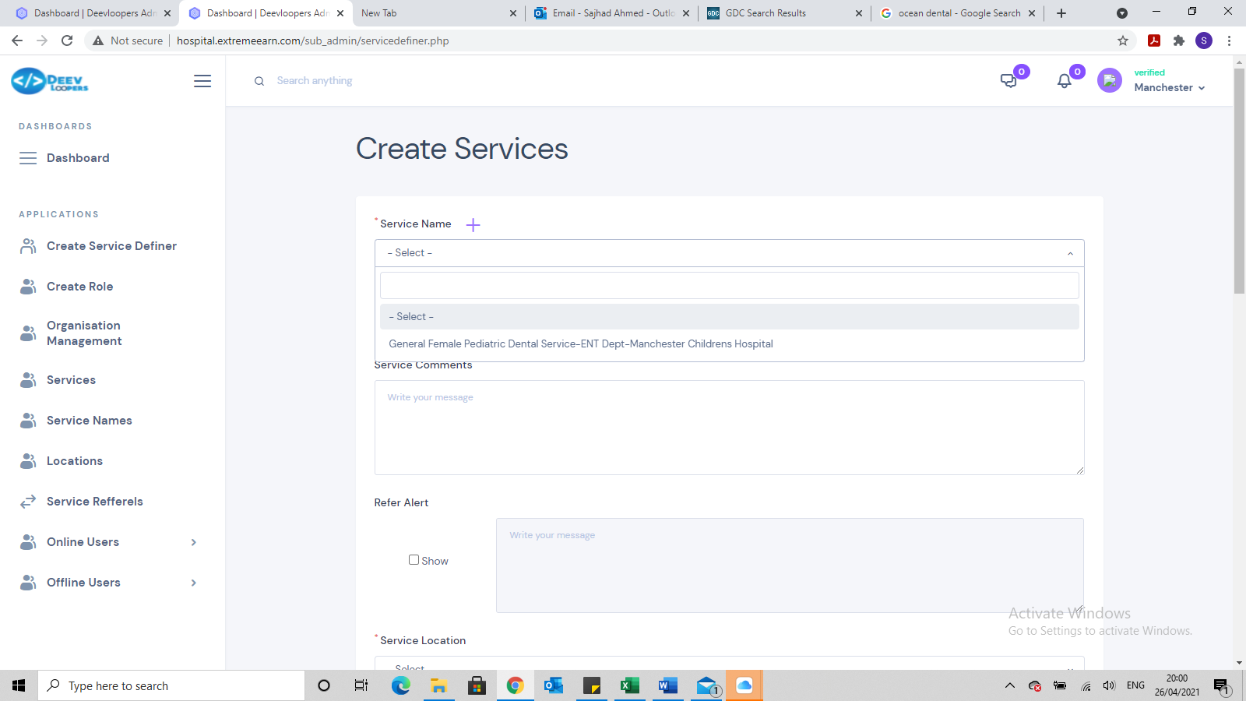

When trying to create another service 1 of the existing one is available, this should not be available

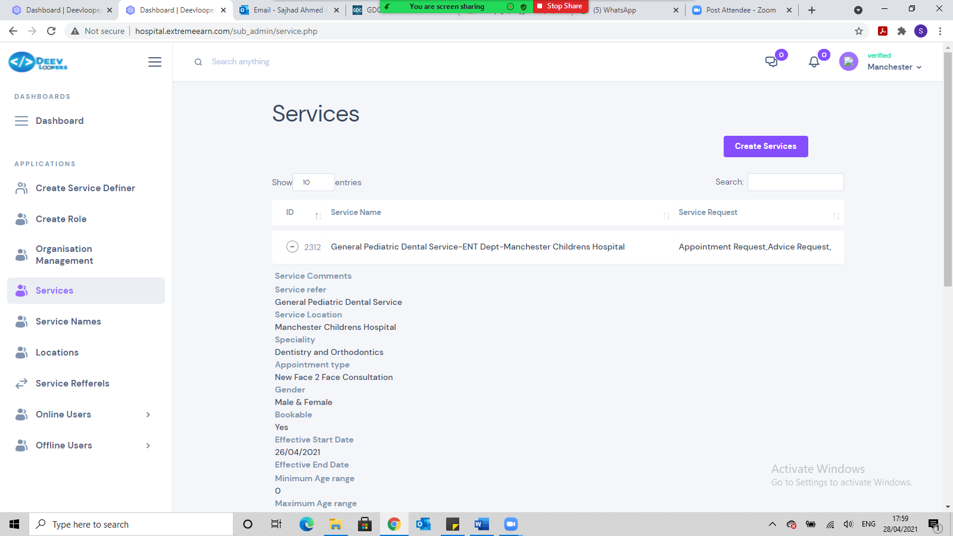

* Please redesign page as discussed

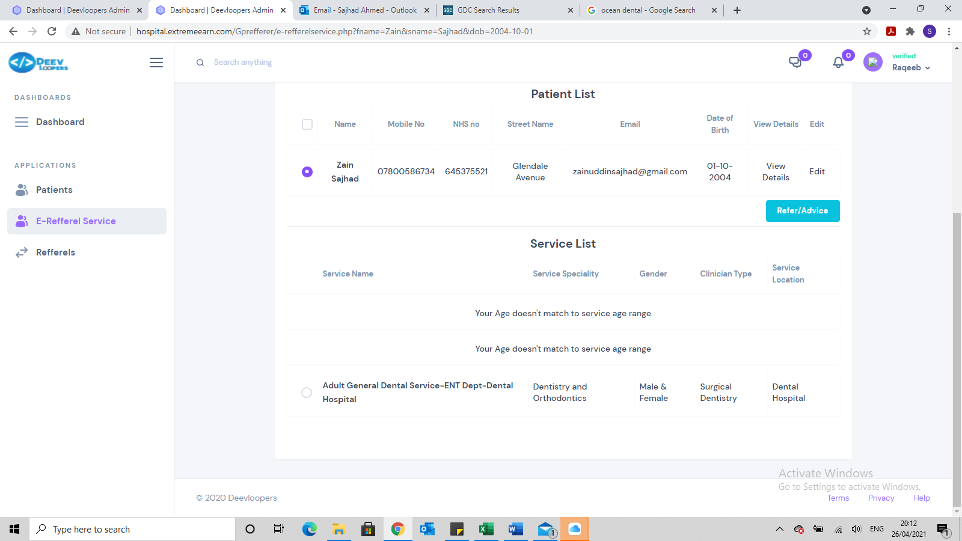

The age condition has worked, but need to remove the words

***Your Age doesn’t match to service age range***

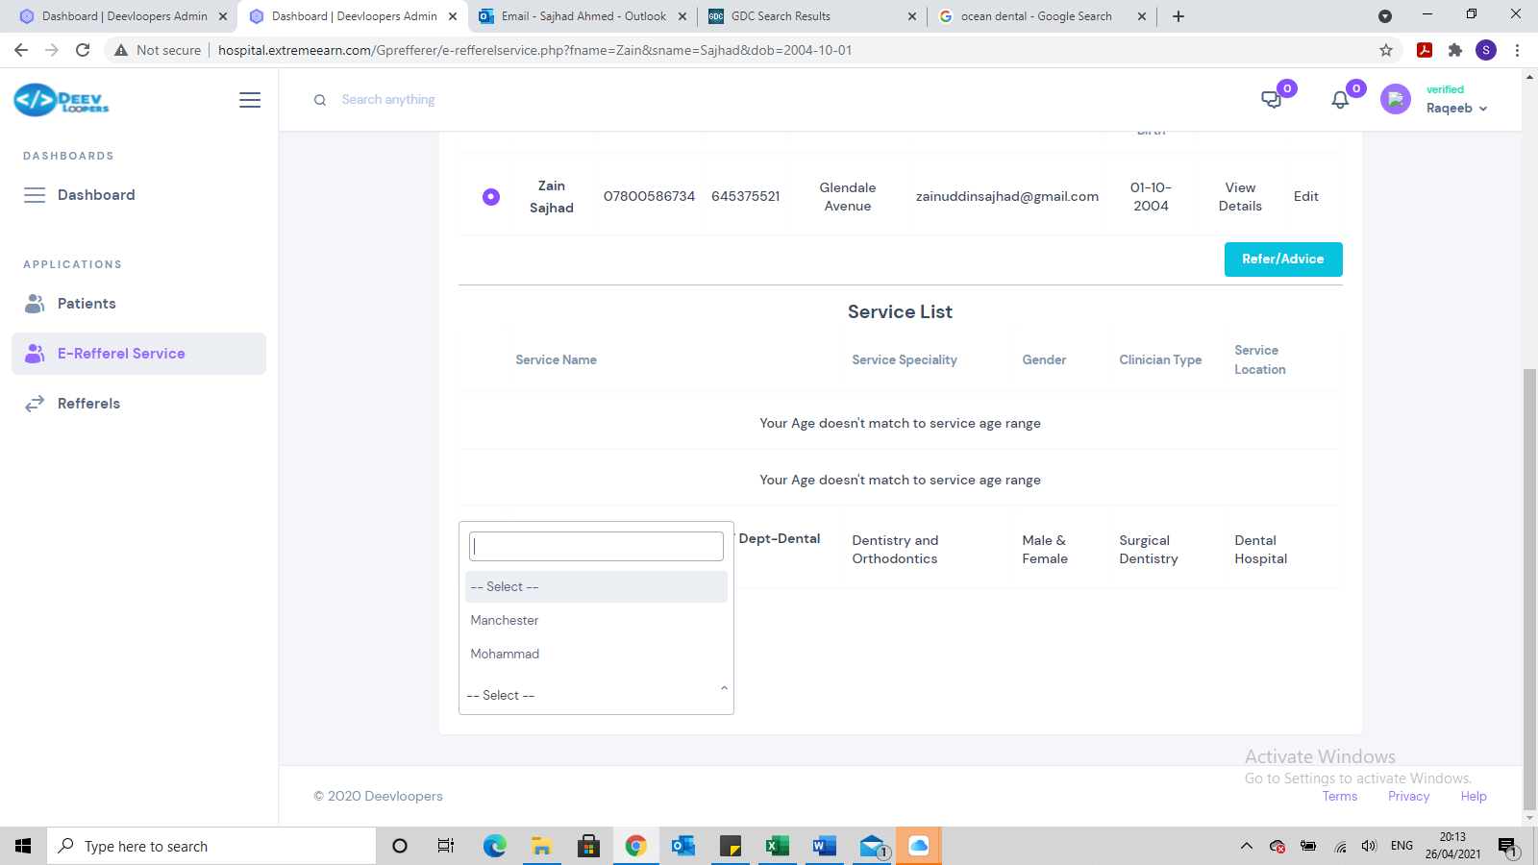

***Still getting an issue with Consultant and also we need to link it at Service stage***

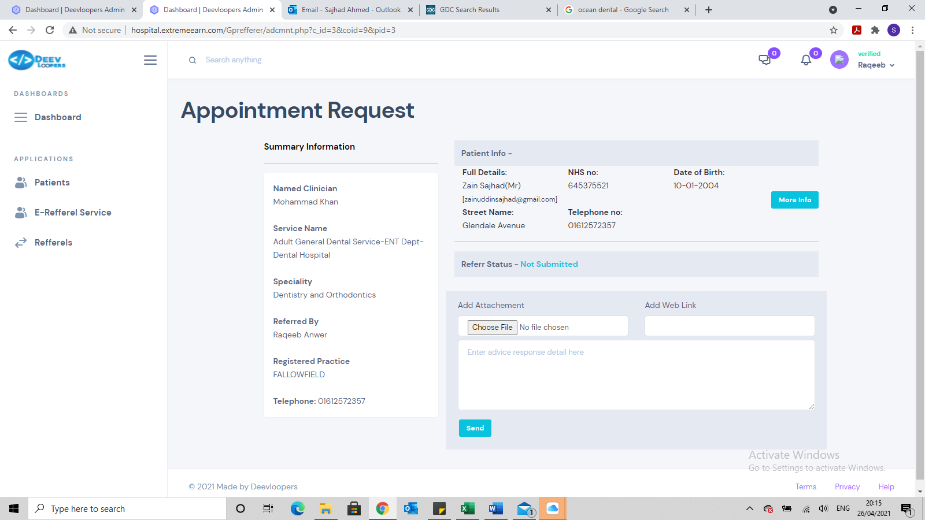

**We need:**

* **Registered practice full name to come across**
* **Telephone number is patients, but should be practices**
* **It is submitting again before clicking on send**
* **Send Referral**
* **Save as draft**
* **Cancel referral (are you sure you want to cancel this referral)**

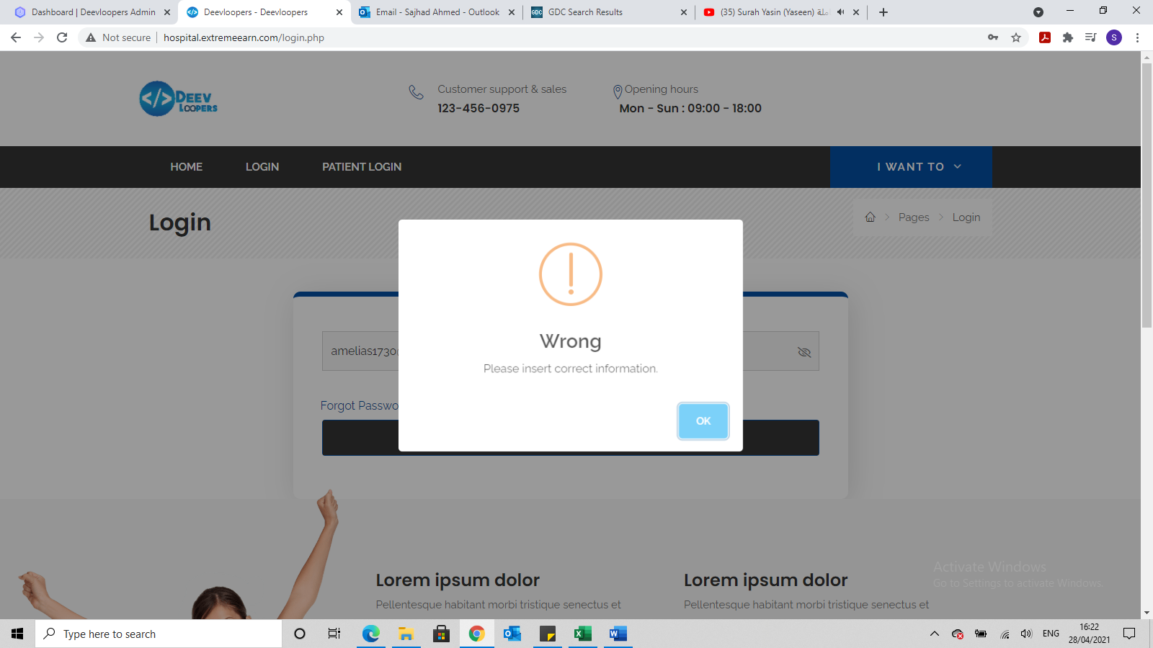

**Change this wording to Username or Password not recognised. Please try again or contact IT.**

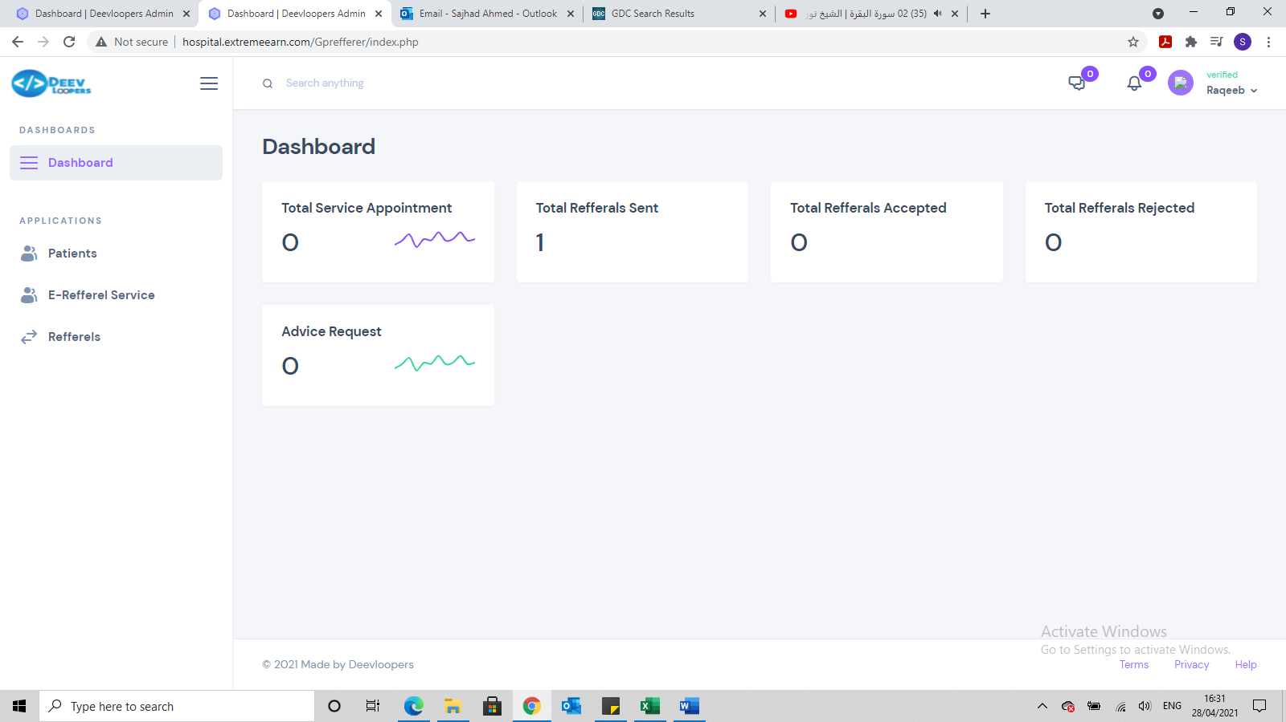

The referrer’s dashboard shows a referral has been sent but unable to click into it.

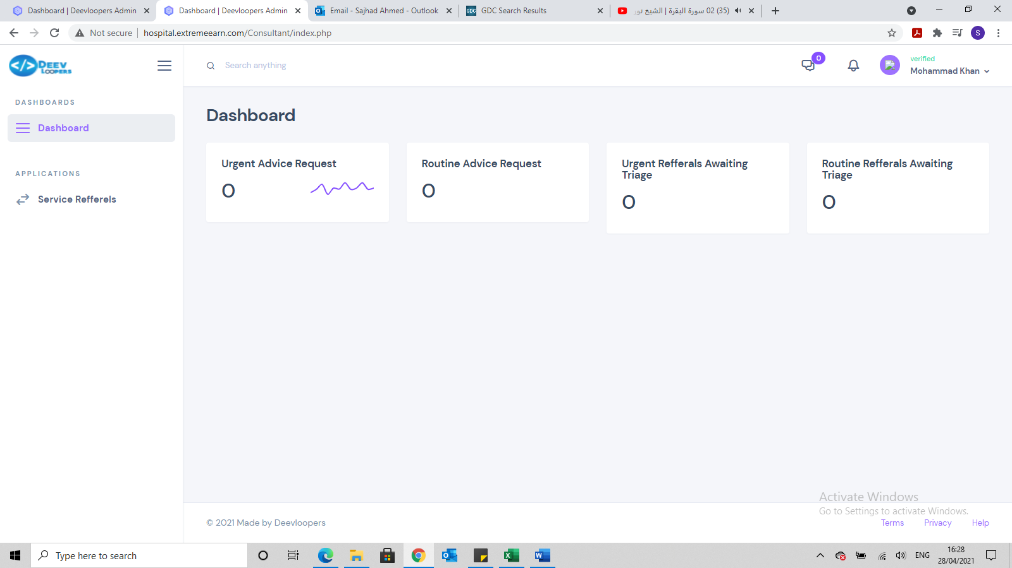

**Hospital consultant dashboard shows no referrals but when clicking on Service referrals it shows there is a referral awaiting triage**

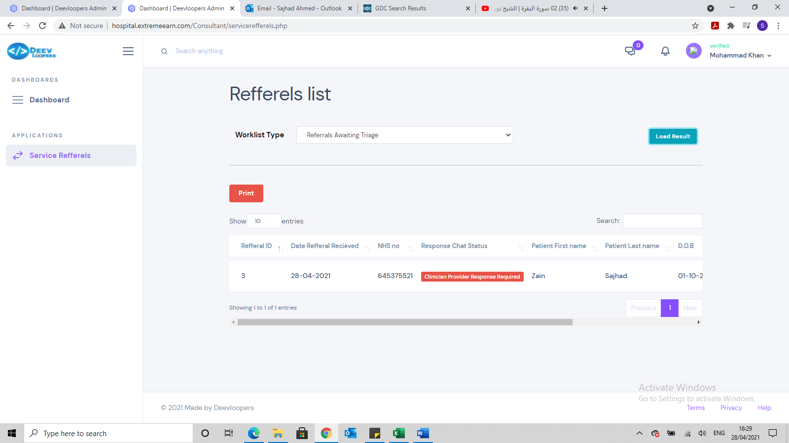

Showing referral awaiting triage.

Also the design needs to completely changed

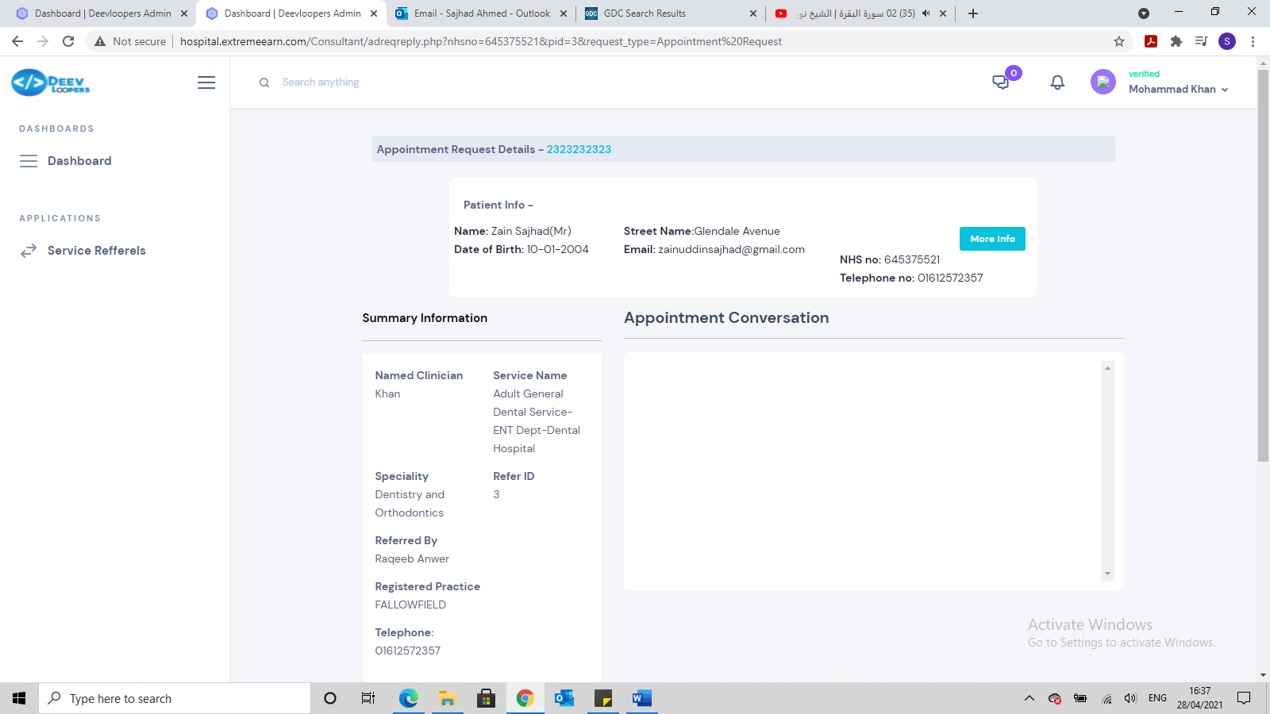

A number of changes required on this page:

* Appointment request details – whats this number? We don’t need it
* Patient info box is not lined up properly
* Summary information
  + Requires Consultant full name not just surname
  + Refer ID, should be Referral ID
  + Registered Practice should have full name of Practice
  + Telephone number should be Practice number not patients

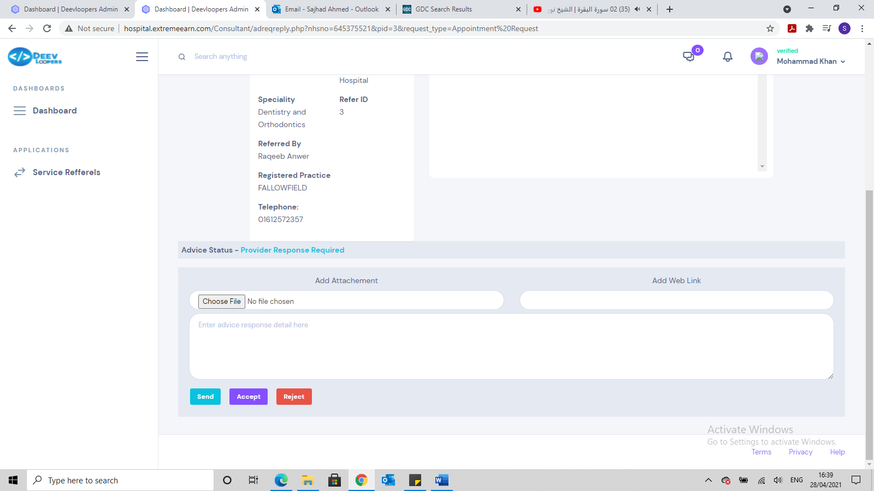

This needs to be redesigned:

* We do not need the bottom box – please remove it
* Option should be either
  + Accept (if accept, then no further information required, just accept and it moves to next referral)
  + Reject (if reject then requires a box to come up, so a rejection reason can be typed.)
  + Login should automatically, log someone out after 10 mins of inactivity, rather than it hanging until someone clicks on to it and then it logs u out
  + When rejecting the page doesn’t automatically close the referral, it stays at the same point. This needs to change.

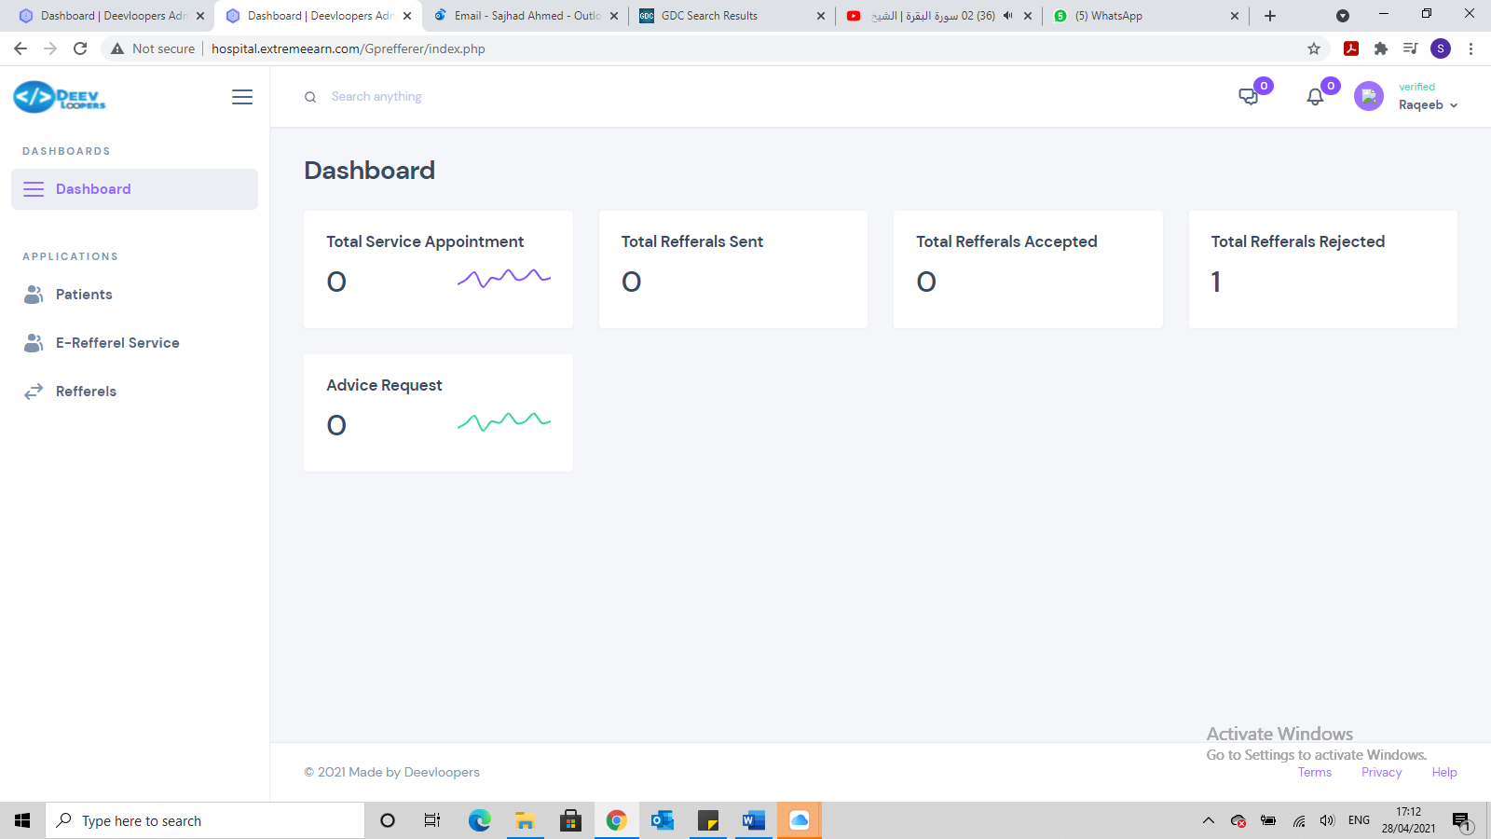

* Dashboard shows Total Referrals Rejected but need to be able to click into it.

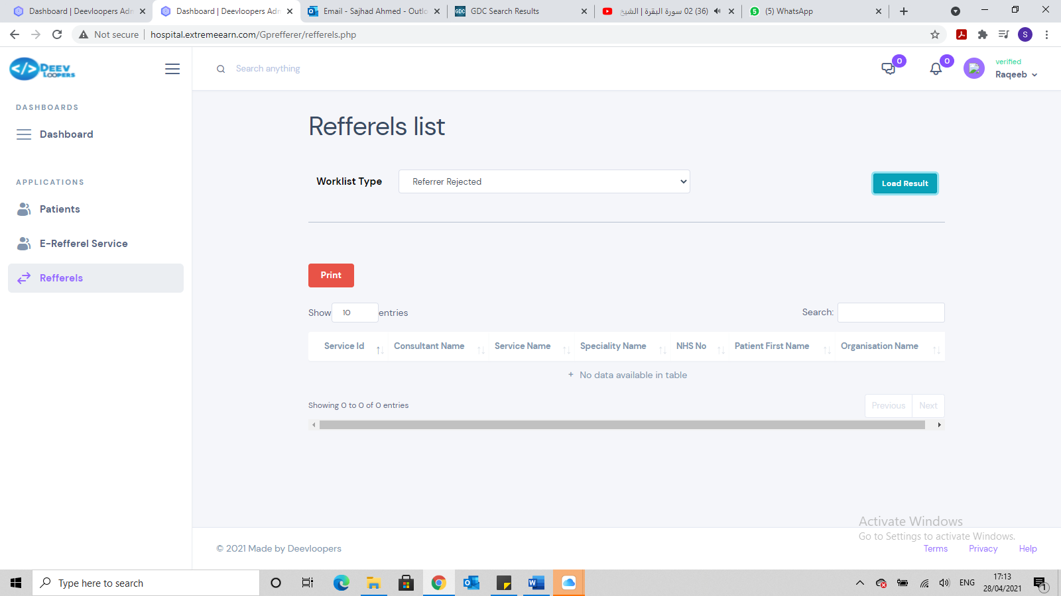

* But when clicking into rejected referrals, it doesn’t show?

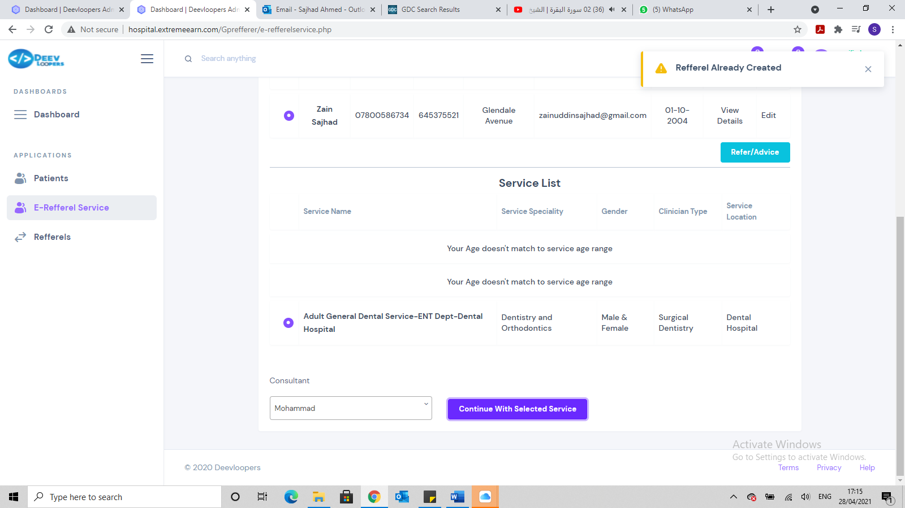

* Won’t allow for more than 1 referral to be created for the same patient.
* It should say, this patient has already had a (speciality name) referral, do you want to refer the patient again?

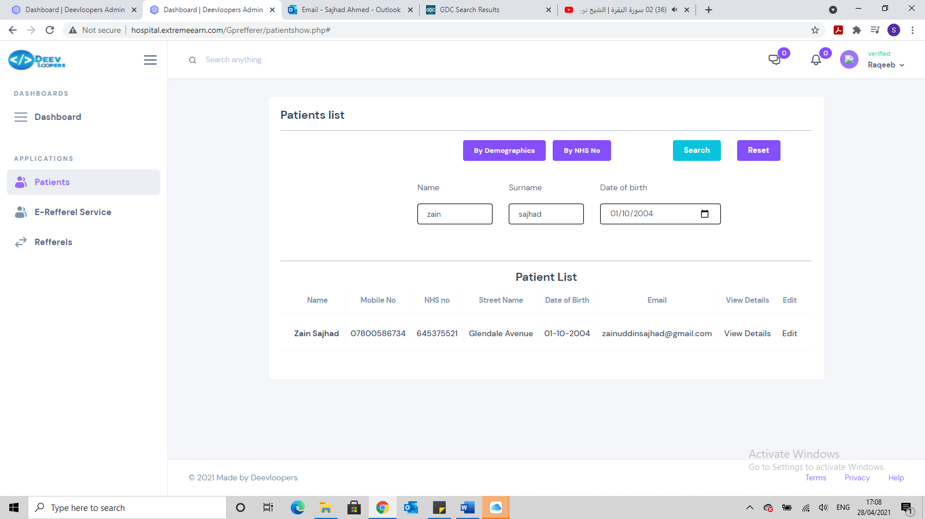

* Should be able to click on patient record and it opens into new page with all patients details.
* Also once click into, it should show all the referrals for this patient from this practice but no other practice referrals.